Position Justification Effects on Source Bias Supplemental Materials

Table of Contents
Study Demographics 2
Factor Analysis Details 3
Eigenvalue and Parallel Analysis Information for Factor Analyses 4
Second part of Study 4: Perceived Carry-Over to Different Message Topics 6
Second part of Study 5: Perceived Carry-Over to Different Message Topics 11
Moderated Mediation with research assistant coded thoughts (Back end of Study 9) 15
Exploratory amount of processing effects in persuasion results 18
Individual Study Results 23
Effects of Argument Quality Manipulation on Perceptions of Bias controlling for alternative perceptions for Front Ends of Studies 2-9 23
Perceptions of bias at time 2 as a function of initial perceptions of bias, time 2 argument quality, and their interaction controlling for pre-message attitudes for individual Studies 6-8 26
Results with an index of perceived bias that includes the perceived objectivity item 27
Argument Quality Effects on Source Perceptions in Study 1 27
Argument Quality Effects on Source Perceptions in Studies 2-9 28
Perceived Bias Carry-Over: Backend of Studies 6, 7, and 8 30
Influences of Source Bias on Persuasion on a New Topic: Backend of Study 9 32

Study Demographics

Table S1. Demographic information for each study
 | Study 1 | Study 2 | Study 3 | Study 4 | Study 5 | Study 6 | Study 7 | Study 8 | Study 9
Gender
%Male | 37.50 | 50.0 | 43.00 | 48.10 | 40.20 | 50.70 | 39.70 | 40.30 | 44.40
% Female | 62.50 | 50.0 | 57.00 | 51.90 | 59.80 | 49.30 | 60.30 | 59.70 | 55.60
Race
%White | 76.20 | 74.50 | 66.80 | 81.00 | 78.00 | 80.90 | 74.30 | 82.40 | 80.90
%Black | 9.30 | 12.70 | 9.80 | 3.80 | 8.70 | 9.90 | 13.60 | 7.40 | 7.80
%Asian | 7.70 | 4.90 | 19.20 | 8.90 | 7.70 | 4.60 | 4.40 | 5.10 | 4.40
%Native American | .80 | 2.00 | 0.00 | 1.30 | .70 | .40 | 1.90 | 0.00 | 1.50
%Pacific Islander | 0.00 | 0.00 | 0.00 | 0.00 | 0.00 | 0.00 | .50 | 0.00 | 0.00
%Mixed | 4.40 | 5.88 | 3.10 | 5.10 | 3.50 | 3.90 | 2.90 | 3.40 | 4.40
%Other | 1.60 | 0.00 | 1.00 | 0.00 | 1.40 | .40 | 2.40 | 1.70 | 1.00
Ethnicity
%Hispanic or Latino | 7.70 | 11.80 | 6.70 | 20.30 | 7.70 | 5.70 | 9.30 | 6.30 | 6.00
%Not Hispanic or Latino | 92.30 | 88.20 | 93.30 | 79.70 | 92.30 | 94.30 | 90.70 | 93.80 | 94.00
Age (M, SD) | 35.42, 12.81 | 36.74, 12.38 | 20.66, 2.94 | 35.86, 11.55 | 37.18, 13.13 | 36.79, 13.60 | 38.27, 13.64 | 36.29, 12.17 | 38.37, 13.71
Political Affiliation
Democrat | 41.90 | 42.20 | - | 44.30 | 42.30 | 42.80 | 39.60 | 42.00 | 48.80
Republican | 16.80 | 16.70 | - | 22.80 | 21.30 | 17.90 | 23.20 | 22.70 | 14.60
Independent | 30.30 | 35.30 | - | 29.10 | 29.70 | 33.00 | 30.00 | 31.80 | 31.70
Other | 11.10 | 5.90 | - | 3.80 | 6.60 | 6.30 | 7.20 | 3.40 | 4.90

Factor Analysis Details

We began by examining a scree plot and a parallel analysis for each set of data, including measures of perceived bias, trustworthiness, and expertise (the only measures we had) for the first set and measures of perceived bias, trustworthiness, expertise, intelligence, and liking for the second set. The eigenvalues were computed from the reduced correlation matrix. Although interpreting scree plots is a subjective endeavor, they seemed to suggest three factors in the first set and four factors in the second set (see Figures S2-S5 in the Online Supplement). The parallel analyses (that compare the obtained eigenvalues to those from random data and, therefore, might represent a maximum number of major factors) suggested that there should be no more than three factors in the first set and five factors in the second set. Model fit using Root Mean Square Error of Approximation (Steiger, 1990), also suggested that fit approached or reached more acceptable levels as the number of factors increased to 3 and to 5 factors, respectively in the two sets of data. Given these indicators and our theorizing, we present a three-factor solution for the first set of studies (Table 2) and a five-factor solution for the second set of studies (Table 3), in part because the oblique rotation would allow us to see strong correlations between any factors that would have combined in a four-factor solution. To conduct this factor analysis, we used the ‘psych’ package in R. We used a maximum likelihood estimation approach, factor loadings are based on the pattern matrix, and the factors are rotated using an oblimin transformation with Kaiser normalization.

Eigenvalue and Parallel Analysis Information for Factor Analyses
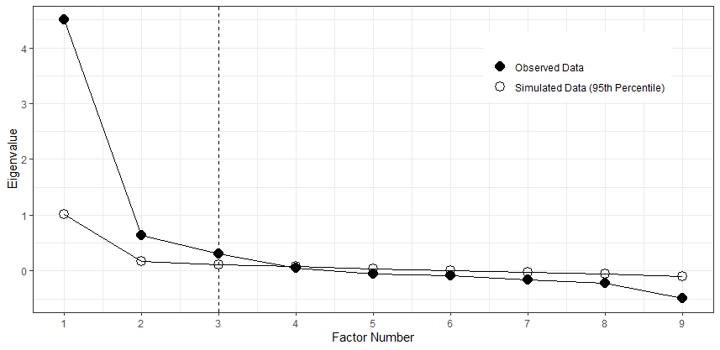
Figure S1. Scree Plot and Parallel Analysis for studies that did not include measures of perceived liking and intelligence

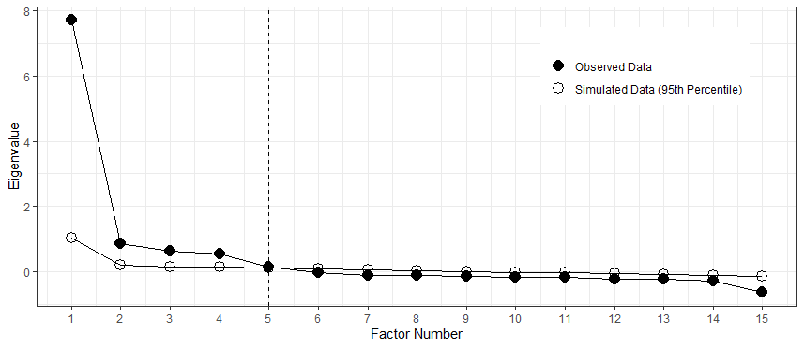
Figure S2. Scree Plot and Parallel Analysis for studies that included measures of perceived intelligence and liking

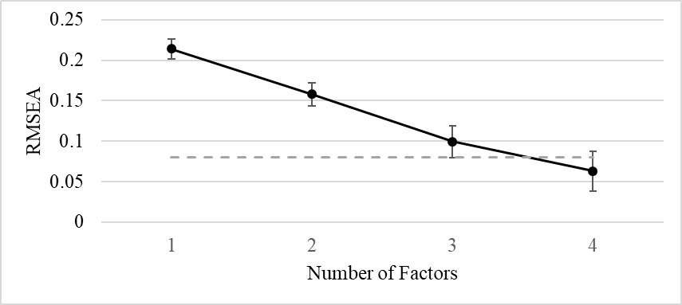
Figure S4. RMSEA values for solutions with each number of factors for studies that did not include measures of perceived intelligence and liking. Error Bars indicate the 90% confidence interval around each RMSEA estimate. Dotted gray line is plotted where RMSEA = .08, a value that is generally considered to indicate acceptable fit.

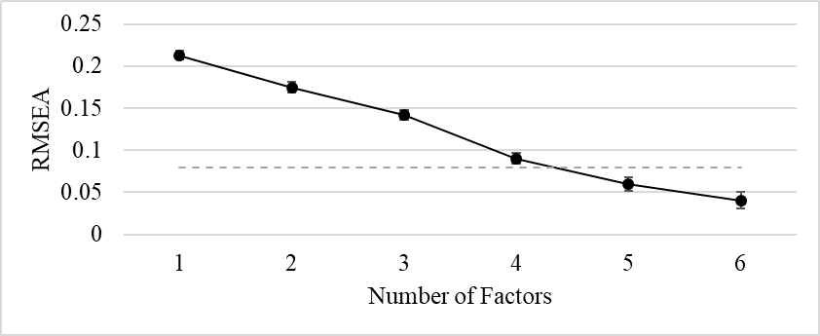
Figure S5. RMSEA values for solutions with each number of factors for studies that did include measures of perceived intelligence and liking. Error Bars indicate the 90% confidence interval around each RMSEA estimate. Dotted gray line is plotted where RMSEA = .08, a value that is generally considered to indicate acceptable fit.

Second part of Study 4: Perceived Carry-Over to Different Message Topics
In the second part of several studies, we sought to examine whether a perception of bias on one topic might persist when the source provided a second message on a different topic. It is common in everyday life to receive multiple messages from the same source. For example, celebrities endorse both products and politicians. Though people may perceive messages they provide about politicians or policies as related to a political bias they might have, people may be less likely to view the celebrity’s endorsement of a consumer product as related to their political bias. However, people may be aware of previous endorsements that a source has made when they receive a message on a new topic. For example, many Americans were aware that Oprah endorsed President Obama in 2008, but Oprah also endorses many consumer products, including Weight Watchers. If a message recipient had perceived the initial endorsement of President Obama as a product of bias, would that perception carry over to the endorsement of Weight Watchers? We hypothesized that bias might be particularly likely to carry over when the topic of the second message seemed relevant to whatever bias the source seemed to possess. For example, if a recipient perceived that a source had a political bias based on a message the source provided about a political candidate, the recipient might infer that the bias extended to other political topics, but not to topics unrelated to politics. As such, in the second part of Study 4, we wanted to test the hypothesis that bias would carry over to more related topics, but not so much to less related topics.
Method.
Design and procedure. After completing the first part of the study as described in the text, participants were told that many times in life people receive messages on a range of topics from the same person and were asked to imagine that Cami (the source) provided a second message after the one in support of Ben Patton. We explained that we would present them with a number of topics and would like for them to imagine that Cami provided a message on that topic after her message about Ben Patton. Then, participants rated the extent to which they would perceive Cami as biased (1 = not at all, 9 = very much) if she provided a message about nine different topics. In a pretest, participants rated how relevant each topic was to a political bias (1 = not at all, 9 = very much). Three of the topics (i.e., another political candidate from her own party, federal tax policy, and gun rights) had been rated as quite relevant to a political bias (Ms = 6.87, 6.81, 6.89). Three of the topics (i.e., a county-level program to address a local heroin epidemic, implementing a county recycling program, and a county transportation initiative) had been rated as moderately relevant (Ms = 5.36, 5.36, 5.30), and three of the topics (i.e., a local bike shop, a painting, and coffee) had been rated as relatively low in relevance (Ms = 3.04, 2.97, 2.75). The topics were grouped by relevance category and the categories were counterbalanced across participants. After participants reported the extent to which they would see Cami as biased on that topic, they rated each of the topics on the extent to which they perceived them as relevant to whatever political bias a person might have (1 = not at all, 9 = very much) in the same order in which they had answered the questions about Cami’s bias.
Results. First, we checked our manipulation of relatedness by conducting a within-participants General Linear Model (GLM) examining the average relatedness ratings for each pretested level of relatedness. An omnibus test demonstrated that there were differences among the levels of relatedness, F(2, 156) = 44.32, p < .001. Those topics that were intended to be most related to a bias (M = 6.53) were seen as more related than those intended to be moderately related (M = 5.63), F(1, 78) = 24.27, p < .001. The moderately related topics were perceived as more related than those intended to be the least related (M = 4.26), F(1, 78) = 37.06, p < .001.
Next, to test our hypothesis that bias carry over would be moderated by the relatedness of the second topic, we conducted a Mixed GLM with relatedness as a three-category within-subjects factor, initial perceptions of bias (measured immediately after Cami’s first message) as a continuous predictor, and their interaction predicting perceptions of bias on the novel topics. Recall that we had initially measured perceived bias at Time 1 with three items (the two perceived bias items and one reverse-coded perceived objectivity item). However, the factor analysis showed that the objectivity item did not load highly with the others. As such, the following results presentation reports the two-item bias composite as the predictor as the main analysis, but the results with the composite including the objectivity item as the predictor are in parentheses.
There was a main effect of relatedness, F(2, 76) = 13.85, p <. 001, (F(2, 76) = 14.37, p < .001), and a main effect of initial perceived bias, F(1, 77) = 29.59, p < .001, (F(1, 77) = 17.62, p < .001). There was a trending interaction (significant with composite including the objective item) between relatedness and initial perceptions of bias, F(2, 76) = 2.11, p = .13, (F(2, 76) = 6.40, p = .003). Simple effects demonstrated that initial perceptions of bias descriptively had a larger effect on perceptions of bias after the second message on the highly related topic, b = .57, t(77) = 6.87, p < .001 (b = .58, t(77) = 6.52, p < .001), than on the moderately, b = .39, t(77) = 4.00, p < .001 (b = .27, t(77) = 2.45, p = .02), or least related topics, b = .43, t(77) = 3.47, p = .001 (b = .35, t(77) = 2.61, p = .01). The difference between the moderate and least related topics was not significant, F(1, 77) = .19, p = .66 (F(1, 77) = .72, p = .40). As such, we collapsed across the moderately and least related categories when comparing them to the most related topics. The most related topics demonstrated marginally more carry over than the moderately and least related topics, F(1, 77) = 3.17, p = .08 (F(1, 77) = 8.88, p = .004).
Next, as an exploratory test, we examined whether these results were moderated by the order in which participants saw the attitude objects. A Mixed GLM with relatedness as a three-category within-subjects factor, order as a between-subjects factor, and initial perceptions of bias as a continuous predictor, as well as their corresponding two- and three-way interactions predicting perceptions of bias on the additional topics identified an interaction among relatedness, order, and initial perceptions of bias, F(4, 146) = 2.68, p = .03 (F(4, 146) = 2.80, p = .03). When participants saw the most related items before the moderately or least related items, there was a significant relatedness by initial bias interaction, F(2, 26) = 3.27, p = .05 (F(2, 26) = 5.65, p = .009), such that the bias carried over to the most related items, b = .46, t(27) = 3.72, p = .001 (b = .57, t(27) = 4.54, p < .001), but not the moderately, b = .15, t(27) = .86, p = .40 (b = .03, t(27) = .15, p = .88), or least related items, b = -.19, t(27) = -.72, p = .48 (b = -.25, t(27) = -.93, p = .36). However, when they saw the moderately related items followed by the least and then most related items, the initial bias by relatedness interaction became non-significant, F(2, 22) = 2.44, p = .11 (F(2, 22) = 3.02, p = .07). There was still significant bias carry over among the highly related items, b = .61, t(23) = 3.62, p = .001 (b = .57, t(23) = 2.92, p = .008), moderately related items, b = .42, t(27) = 2.46, p = .02 (b = .29, t(23) = 1.48, p = .15) and the least related items, b = .72, t(23) = 3.77, p = .001 (b = .59, t(23) = 2.56, p = .02). Finally, when they saw the least related items followed by the most and then moderately related items, there was no significant interaction between relatedness and initial perceptions of bias, F(2, 22) = .15, p = .87 (F(2, 22) = .61, p = .55). The initial bias carried over to the new topics regardless of whether they were high, b = .62, t(23) = 4.43, p < .001 (b = .60, t(23) = 4.00, p = .001), moderate, b = .60, t(23) = 3.59, p = .002 (b = .46, t(23) = 2.45, p = .02), or low, b = .70, t(23) = 4.14, p < .001 (b = .63, t(23) = 3.44, p = .002), in relatedness. In general, this pattern of data suggests that if participants received highly related topics first, they were less likely to apply initial bias to unrelated topics. This is consistent with a topic-related attribution of bias: the bias should only carry over to topics perceived as related to the bias. However, when they received unrelated topics first, they applied the bias to even seemingly unrelated topics. Interestingly, this suggests that bias can carry over to seemingly unrelated topics as long as people do not have a comparison to something more related to suggest to them that broad application of the bias might not be appropriate. This is consistent with a person attribution of bias when people are not considering topic relatedness per se. In such settings, it seems that there is something about the source that makes them seem particularly susceptible to biases in general.

Second part of Study 5: Perceived Carry-Over to Different Message Topics
On the back end of Study 5, we wanted to provide a confirmatory test of the unexpected order by relevance by initial perceptions of bias interaction. Further, we wanted to instantiate the conditions that might produce the relevance by initial bias interaction in a novel manner. In order to do this, we created conditions in which some participants were “forewarned” that a source provides information on many topics, some of which may be related to a bias and some of which may not.
Method.
Design and procedure. Study 5 was identical to Study 4 with two exceptions. First, participants were only presented with the topics most and least related to political bias from Study 4. Second, and more importantly, in one condition, participants were forewarned about the range of topics on which Cami could possibly provide a second message. The listed topics included the most and least related topics from Study 4. This condition was intended to create a situation in which bias would likely not carry over to less related topics because people would have the more related topics in mind as a comparison (as they presumably did when rating highly-related topics first in the order effect in Study 4). Everyone alerted to this range had the same range in mind due to the listing of the same related and unrelated topics for everyone in that condition.
Results. First, we conducted a Mixed GLM where the within-subjects factor was a two-category topic relatedness to political bias variable (related vs. unrelated) and the between-subject variables were initial perceptions of bias (measured immediately after Cami’s first message) as a continuous predictor variable, order of related versus unrelated topics and whether they were forewarned as between-subjects factors, as well as all the corresponding two-, three-, and four-way interactions predicting perceptions of bias on the novel topics. We expected clear differentiation across topic relatedness (more carry-over to related than unrelated topics) when participants were forewarned of the range of potential topics or encountered the highly-related topics first when participants were not forewarned (as in Study 4). In contrast, we expected weak or nonexistent differentiation between related and unrelated topics in the other cell. The simple topic relatedness effects within the various combinations of forewarning and order showed exactly the expected pattern (see Figure S3 below). As in the previous study, we present analyses with the two-item bias composite as the primary analysis, but results with the composite including the objectivity item are reported in parentheses.
For participants who were forewarned of the range of topics, there was no significant interaction between topic relatedness, order, and initial bias, F(1, 138) = .00, p = .98 (F(1, 138) = .01, p = .93). Instead, there was an overall two-way interaction between the relatedness of the topic and initial perceptions of bias, F(1, 138) = 5.76, p = .02 (F(1, 138) = 7.82, p = .006). As the lack of an interaction with order suggests, this topic relatedness by initial bias pattern was present (at least in a trending manner) both when the most related topics were rated first, F(1, 62) = 2.64, p = .11 (F(1, 62) = 3.28, p = .08), and when the least related topics were rated first, F(1, 76) = 3.27, p = .08 (F(1, 76) = 4.90, p = .03). These interactions reflected that the initial bias only carried over for the most related topics, b = .41, t(62) = 4.85, p < .001; b = .40, t(76) = 3.76, p < .001 (b = .45, t(62) = 5.09, p < .001; b = .42, t(76) = 3.75, p < .001), but not the least related topics, b = .21, t(62) = 1.62, p = .11; b = .19, t(76) = 1.90, p = .06 (b = .21, t(64) = 1.54, p = .13; b = .16, t(76) = 1.46, p = .15), in the high versus low relatedness first order conditions, respectively.
However, consistent with Study 4, among those who were not forewarned about the potential topics, the order of topics mattered. That is, there was an interaction among topic relatedness, order, and initial bias, F(1, 140) = 3.89, p = .05 (F(1, 140) = 3.65, p = .06). Participants who rated the related topics first showed the same initial bias by relatedness interaction pattern as found in Study 4, F(1, 74) = 4.33, p = .04 (F(1, 74) = 4.60, p = .04). That is, the initial bias only significantly carried over for the highly related topics, b = .35, t(73) = 4.82, p < .001 (b = .38, t(73) = 4.39, p < .001), but not the least related topics, b = .14, t(74) = 1.24, p = .22 (b = .15, t(73) = 1.17, p = .25). Conversely, when participants rated the unrelated topics first, there was no initial bias by relatedness interaction, F(1, 66) = .57, p = .45 (F(1, 66) = .31, p = .58). Indeed, again mirroring Study 4, the initial bias carried over both for the related topics, b = .46, t(66) = 4.58, p < .001 (b = .47, t(66) = 4.26, p < .001), and the unrelated topics, b = .54, t(66) = 6.01, p < .001 (b = .54, t(66) = 5.26, p < .001).
The four-way interaction did not reach statistical significance, F(1, 278) = 1.79, p = .18 (F(1, 278) = 1.90, p = .17), but a direct comparison of the topic relatedness effects in the three cells where such differentiation was expected (both forewarned cells and the unforewarned cell when highly related topics were encountered first) versus the one cell where topic relatedness differences were not expected showed a significant difference, F(1, 283) = 4.88, p = .03 (F(1, 283) = 4.75, p = .03). Collapsing of the three cells in which bias carry-over depended on relatedness was justified by the lack of Bias X Relatedness X Order interaction between the two forewarned conditions reported above and a lack of difference in the Bias X Relatedness effect between those two cells (collapsed) and the unforewarned cell in which the unrelated topics came first, F(1, 214) = .013, p = .91 (F(1, 214) = .012, p = .91).
These results further support the hypothesis that people will often perceive a source who is biased in one context as biased in another context. When perceivers realize that some topics are more related to the original bias than are others, this carry-over of bias from one topic to another is especially present across related topics, consistent with a topic-related attribution of bias. Interestingly, it seems that people will even carry a bias over to a relatively unrelated topic if they do not have a more related topic as a point of comparison, consistent with person attributions of bias when topic relatedness is not considered.

Figure S3. Interaction between whether participants were forewarned about the topics, order of ratings, relatedness of the topic, and initial bias in Study 5.
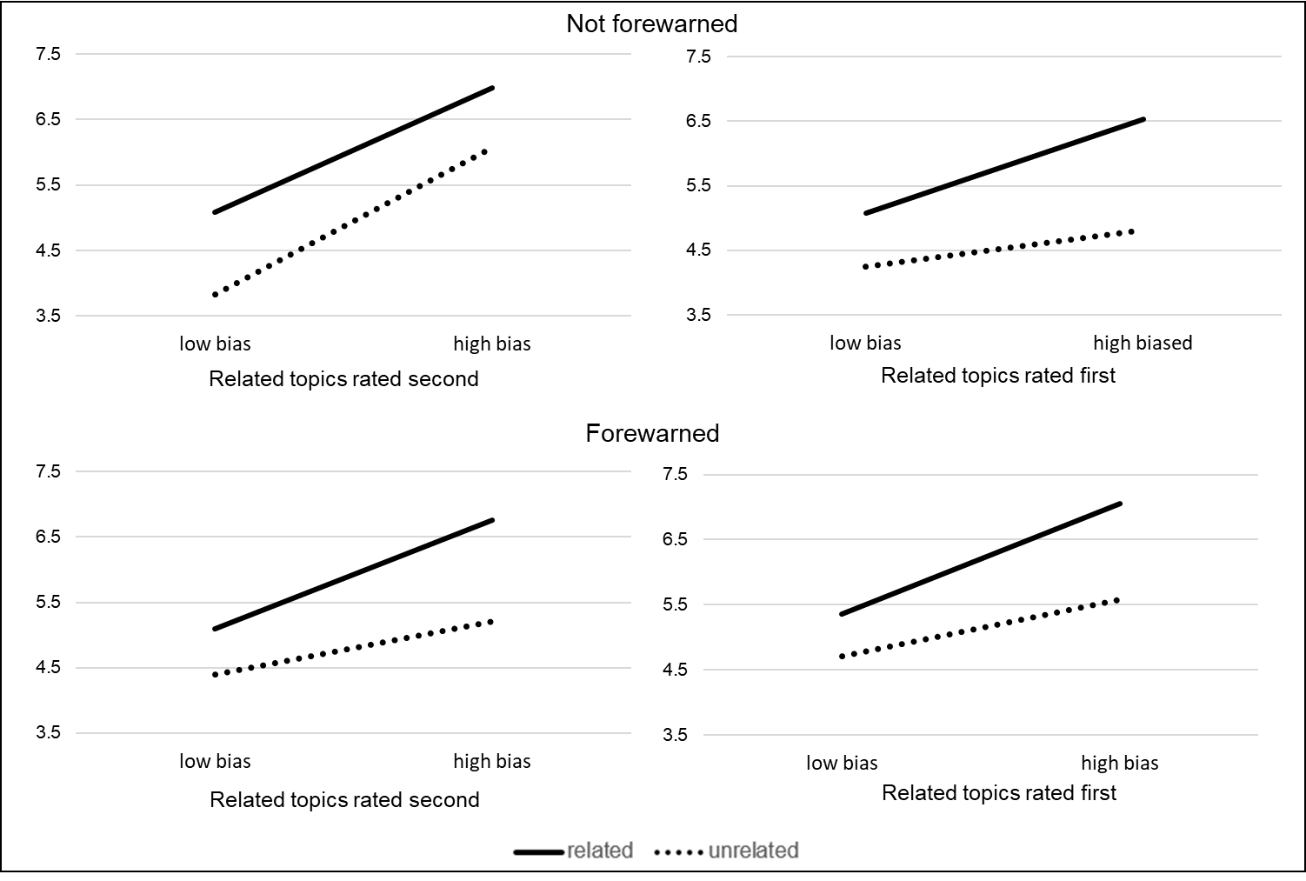

Moderated Mediation with research assistant coded thoughts (Back end of Study 9)
In a model with perceived bias, each of the argument quality variables, their corresponding interactions, and pre-message attitudes predicting research-assistant coded thoughts, there were not main effects of bias, b = -.01, t(198) = -.37, p = .71, or the argument quality variable comparing the mixed arguments to the strong and weak arguments, b = .04, t(198) = 1.19, p = .24. There were significant main effects of the argument quality variable comparing the strong to the weak arguments, b = .14, t(198) = 2.40, p = .02, and pre-message attitudes, b = .09, t(198) = 4.64, p < .001. Most importantly, there was a significant interaction between perceptions of bias and the mixed vs strong and weak argument quality variable, b = .05, t(198) = 2.36, p = .02, but not significantly between perceptions of bias and the strong versus weak argument quality variable, b = .04, t(198) = 1.17, p = .24. The effect of perceived bias on thoughts was significant when participants read the mixed message, b = -.10, t(198) = -2.20, p = .03, but not when they read the weak arguments, b = .00, t(198) = .03, p = .97 or the strong arguments, b = .07, t(198) = 1.51, p = .13.
When we regressed post-message attitudes on perceptions of bias, the argument quality variables, their corresponding two-way interactions, thoughts, and pre-message attitudes, there was a significant effect of thoughts on post-message attitudes, b = 1.93, t(197) = 10.61, p < .001, suggesting high elaboration. Pre-message attitudes also had a significant effect on post-message attitudes, b = .56, t(197) = 10.63, p < .001, but nothing else in the model was significant. The indirect effect in the mixed message condition was statistically significant using 10,000 bootstrap 95% confidence intervals, b = -.20, 95% CI [-.38, -.03]. The indirect effects in the strong, b = .13, 95% CI [-.03, .32] and weak conditions, b = .00, 95% CI [-.18, .18], were not statistically significant.

Exploratory amount of processing effects in persuasion results
We predict that perceptions of bias should be able to influence persuasion through each of the mechanisms outlined by the elaboration likelihood model (Petty & Cacioppo, 1986). As such, we wanted to examine an additional mechanism through which perceptions of bias could influence persuasion: amount of processing. The elaboration likelihood model argues that one role that source characteristics can play is to increase or decrease elaboration on the message. When elaboration is high, participants should be able to distinguish between strong and weak arguments, resulting in increased persuasion in the strong argument condition and decreased persuasion in the weak argument condition. Conversely, when elaboration is low, participants should not distinguish between strong and weak arguments. This effect on amount of processing is ultimately quite important. Not only does it influence persuasion outcomes, but research has demonstrated that elaboration on a persuasive message can increase the strength with which attitudes are held (Priester & Petty, 2003). Thus, when a variable increases processing, it can also increase the strength with which that attitude is held. Because the backends of Studies 6, 7, and 8 manipulated argument quality, as is typical for documenting an amount of processing effect, these studies allowed us to test whether perceiving a source as biased would affect the extent to which participants processed the message.
As no research has previously examined the influence of perceptions of bias through amount of processing effects, we did not have clear predictions for the direction of these effects. Based on the previous literature on amount of processing effects, we were able to generate four different predictions. One prediction would be that perceiving a source as biased would decrease overall levels of processing. This would be consistent with research finding that expertise or trustworthiness (other source perceptions linked to credibility) can increase processing because people are more interested in listening to a highly credible source than a non-credible source (Tobin & Raymundo, 2009). Conversely, one might expect that perceiving a source as biased would increase levels of processing. This would be consistent with work finding that untrustworthiness can increase amount of processing (Priester & Petty, 1995). The logic behind this effect is that recipients could easily trust what an honest source says so they do not need to process the message. Conversely, because recipients can’t rely on what an untrustworthy source says, they must process the message to make sure that it makes sense. Similarly, people may want to process a message from a biased source to make sure that it is coherent and not imbued with ideological nonsense.
The above predictions assume that recipients for whom the message is pro- versus counter-attitudinal would make the same processing choices. However, research has demonstrated that message position can moderate amount of processing effects. The discrepancy motives model (Clark & Wegener, 2013) has argued that people who encounter a counter-attitudinal message may be motivated to defend their attitudes. Because messages from highly credible sources are likely to be more threatening, they should increase processing among recipients for whom the message is counter-attitudinal. Conversely, people who encounter a pro-attitudinal message may be motivated to bolster their attitudes. Because pro-attitudinal messages from sources low in credibility could trigger concern that their position would be represented with bad reasons, they should increase processing compared to a high credibility source. Thus, the discrepancy motives model might predict increased processing for biased sources among those for whom the message is pro-attitudinal, but the opposite for those for whom the message is counter-attitudinal.
However, one could generate the opposite hypothesis: if counter-attitudinal messages from highly credible sources are too threatening, people may choose to bolster their attitudes by processing messages from sources low in credibility, as they might expect the arguments to be easier to defend than those from a highly credible source. Conversely, if pro-attitudinal messages from sources low in credibility seem unlikely to help someone bolster their attitude, people may be more likely to process pro-attitudinal messages from sources high in credibility. This perspective would predict increased processing of counter-attitudinal messages from biased sources and increased processing of pro-attitudinal messages from relatively objective sources. In sum, the results of these studies are exploratory and prior to analyzing the results of these studies, we thought 4 hypotheses plausible:
1. An overall increase in amount of processing for biased sources
2. An overall increase in amount of processing for objective sources
3. Increased processing for counter-attitudinal messages from objective sources and for pro-attitudinal messages from biased sources
4. Increased processing for pro-attitudinal messages from objective sources and for counter-attitudinal messages from biased sources

As the methods for these studies were reviewed in the text, we skip immediately to results.
Results. One possible pattern of data would have been an overall interaction between perceptions of bias formed after the initial message and the argument quality of the second message, indicating that perceptions of bias either increase or decrease processing overall compared to perceptions of relative objectivity. However, when we regressed post-message attitudes on initial perceptions of bias, the argument quality of the second message, and their interaction controlling for pre-message attitudes, the results did not support this overall two-way interaction, b = .04, t(592) = 1.09, p = .28. Additionally, there was not a main effect of initial perceptions of bias, b = -.02, t(592) = -.51, p = .61. However, there was a significant main effect of argument quality, b = .35, t(592) = 5.08, p < .001, suggesting relatively high levels of elaboration, and of pre-message attitudes, b = .42, t(592) = 14.35, p < .001.
As mentioned above, previous work has demonstrated that recipients’ pre-message attitudes may moderate amount of processing effects (Clark & Wegener, 2013). As such, we wanted to examine a three-way interaction between pre-message attitudes, initial perceptions of bias, and the argument quality of a second message on post-message attitudes. As such, we regressed post-message attitudes, on these variables, as well as their corresponding two and three-way interactions (see Table S2 below). There was a non-significant three-way interaction between pre-message attitudes, perceptions of bias, and the argument quality of the second message. This interaction reflected that among those who agreed with the source, there was no argument quality by initial perceptions of bias interaction, b = -.001, t(589) = -.02, p = .98. However, among those who disagreed with the source, there was a significant argument quality by bias interaction, b = .11, t(589) = 2.19, p = .03, such that there was a bigger difference in argument quality when the source was perceived as biased (+1 SD from the mean), b = .71, t(589) = 4.65, p < .001, than when the source was perceived as relatively less biased (-1 SD from the mean), b = .24, t(589) = 1.71, p = .09. These results suggest that those who disagreed with the source elaborated more when the source was more rather than less biased. This is consistent with the idea that when people disagree, they may prefer to hear information from a source they expect to be able to easily discredit rather than one that may pose a real threat to their attitudes.
Table S2. Post-message attitudes regressed on initial perceived bias, Time 2 argument quality, and pre-message attitudes, along with their two- and three-way interactions
 | b | t | p
Initial perceptions of bias | -.01 | -.14 | .88
Argument quality | .36 | 5.21 | < .001
Pre-message attitudes | .41 | 13.95 | < .001
bias*argument quality | .05 | 1.48 | .14
attitudes*argument quality | -.05 | -1.66 | .10
bias*attitudes | -.01 | -.87 | .38
bias*attitudes*argument quality | -.03 | -1.83 | .06

Figure S6. Effects of initial perceived bias, Time 2 argument quality, and pre-message attitudes on post-message attitudes in Studies 6-8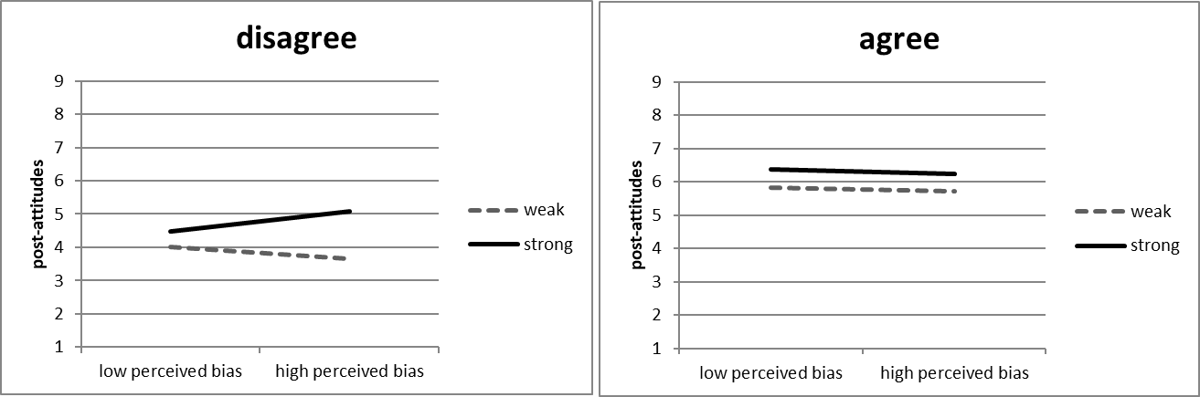

Individual Study Results
Because in the text we present results across combined datasets, in the Online Supplement, we wanted to present results for each individual study. We do this below for both the front end effects of Study 2-9 and the back-end effects of Studies 6-8

Effects of Argument Quality Manipulation on Perceptions of Bias controlling for alternative perceptions for Front Ends of Studies 2-9

Table S3. Panel 1: Effects of the argument quality manipulation on perceived bias, controlling or alternative perceptions and attitudes in Study 2
Predictor |  | Estimate |  | t |  |  | p
Intercept |  | 5.230 |  | 6.525 |  |  | <.001
AQT1 |  | -.449 |  | -2.661 |  |  | .009
attpatt |  | .209 |  | 2.485 |  |  | .015
expert |  | .046 |  | .350 |  |  | .727
trust |  | -.073 |  | -.505 |  |  | .615

Table S3. Panel 2: Effects of the argument quality manipulation on perceived bias, controlling or alternative perceptions and attitudes in Study 3
Predictor |  | Estimate |  | t |  | p
Intercept |  | 5.903 |  | 11.425 |  | < .001
AQT1 |  | -.104 |  | -1.190 |  | .235
attpatt |  | .039 |  | .771 |  | .441
expert |  | -.087 |  | -1.121 |  | .263
trust |  | .211 |  | 2.926 |  | .004
like |  | -.247 |  | -3.017 |  | .003
smart |  | .072 |  | .860 |  | .390

Table S3. Panel 3: Effects of the argument quality manipulation on perceived bias, controlling or alternative perceptions and attitudes in Study 4
Predictor |  | Estimate |  | t |  |  | p
Intercept |  | 4.286 |  | 4.352 |  |  | < .001
AQT1 |  | -.372 |  | -2.078 |  |  | .041
attpatt |  | .345 |  | 3.844 |  |  | .000
expert |  | .109 |  | .761 |  |  | .449
trust |  | -.078 |  | -.522 |  |  | .603

Table S3. Panel 4: Effects of the argument quality manipulation on perceived bias, controlling or alternative perceptions and attitudes in Study 5
Predictor |  | Estimate |  | t |  |  | p
Intercept |  | 7.146 |  | 12.674 |  |  | <.001
AQT1 |  | -.247 |  | -2.053 |  |  | .041
attpatt |  | .189 |  | 3.537 |  |  | <.001
expert |  | -.230 |  | -3.153 |  |  | .002
trust |  | -.186 |  | -2.358 |  |  | .019

Table S3. Panel 5: Effects of the argument quality manipulation on perceived bias, controlling or alternative perceptions and attitudes in Study 6
Predictor |  | Estimate |  | t |  |  | p
Intercept |  | 7.710 |  | 15.594 |  |  | < .001
AQT1 |  | -.489 |  | -4.490 |  |  | < .001
attpatt |  | .162 |  | 3.542 |  |  | <.001
expert |  | -.269 |  | -3.965 |  |  | < .001
trust |  | -.226 |  | -3.106 |  |  | < .001

Table S3. Panel 6: Effects of the argument quality manipulation on perceived bias, controlling or alternative perceptions and attitudes in Study 7
Predictor |  | Estimate |  | t |  | p
Intercept |  | 8.094 |  | 10.399 |  | < .001
AQT1 |  | -.392 |  | -2.540 |  | .012
attpatt |  | .104 |  | 1.584 |  | .115
expert |  | -.038 |  | -.374 |  | .709
trust |  | -.158 |  | -1.236 |  | .218
like |  | -.072 |  | -.575 |  | .566
smart |  | -.157 |  | -1.511 |  | .133

Table S3. Panel 7: Effects of the argument quality manipulation on perceived bias, controlling or alternative perceptions and attitudes in Study 8
Predictor |  | Estimate |  | t |  | p
Intercept |  | 7.686 |  | 10.838 |  | < .001
AQT1 |  | -.499 |  | -3.410 |  | .001
attpatt |  | .153 |  | 2.368 |  | .019
expert |  | -.084 |  | -.697 |  | .487
trust |  | -.220 |  | -1.481 |  | .140
like |  | -.227 |  | -1.689 |  | .093
smart |  | .076 |  | .662 |  | .509

Table S3. Panel 8: Effects of the argument quality manipulation on perceived bias, controlling or alternative perceptions and attitudes in Study 9
Predictor |  | Estimate |  | t |  | p
Intercept |  | 6.541 |  | 11.753 |  | < .001
AQT1 |  | -.304 |  | -2.889 |  | 0.004
attpatt |  | .218 |  | 4.247 |  | < .001
expert |  | -.134 |  | -1.766 |  | .079
trust |  | .014 |  | .162 |  | .872
like |  | -.095 |  | -.963 |  | .337
smart |  | -.068 |  | -.701 |  | .484

Perceptions of bias at time 2 as a function of initial perceptions of bias, time 2 argument quality, and their interaction controlling for pre-message attitudes for individual Studies 6-8

Table S4. Perceptions of bias at Time 2 as a function of initial perceived bias, Time 2 argument quality, and their interaction controlling for pre-message attitudes in Study 6
Predictor |  | Estimate |  | SE |  | t |  | p
Intercept |  | 5.623 |  | 0.4659 |  | 42.144 |  | < .001
Grand_bias |  | .207 |  | 0.0551 |  | 3.454 |  | 0.001
AQT2 |  | -.854 |  | 0.1068 |  | -6.840 |  | < .001
preatt |  | -.009 |  | 0.0602 |  | -.134 |  | .893
biasXAQT2 |  | -.069 |  | 0.0550 |  | -1.154 |  | .249

Table S5. Perceptions of bias at Time 2 as a function of initial perceived bias, Time 2 argument quality, and their interaction controlling for pre-message attitudes in Study 7
Predictor |  | Estimate |  | t |  |  | p
Intercept |  | 5.875 |  | 31.863 |  |  | < .001
Grand_bias |  | .148 |  | 1.924 |  |  | .056
AQT2 |  | -.213 |  | -1.305 |  |  | .193
preatt |  | -.165 |  | -1.813 |  |  | .071
biasXAQT2 |  | -.047 |  | -.613 |  |  | .541

Table S6. Perceptions of bias at Time 2 as a function of initial perceived bias, Time 2 argument quality, and their interaction controlling for pre-message attitudes in Study 8

Predictor |  | Estimate |  | SE |  | t |  | p
Intercept |  | 6.125 |  | 0.2640 |  | 27.480 |  | < .001
Grand_bias |  | -.007 |  | 0.0795 |  | -.067 |  | 0.947
AQT2 |  | -1.558 |  | 0.1436 |  | -8.583 |  | < .001
preatt |  | -.080 |  | 0.0478 |  | -1.337 |  | .184
biasXAQT2 |  | -.060 |  | 0.0799 |  | -.612 |  | .542

Results with an index of perceived bias that includes the perceived objectivity item
After discovering that the perceived objectivity item did not load highly with the other perceived bias items, we chose not to present it in the index in the analyses in the text. However, we wanted to make analyses with the perceived bias index that included the objectivity available to readers so report those below.

Argument Quality Effects on Source Perceptions in Study 1

Table S7. Output from regressions of each source perception on the argument quality manipulation only (first row) and on the argument quality manipulation, pre-message attitudes, and the other source perceptions (last seven rows) in Study 1
 | bias |  |  | trust |  |  |  |  | expert |  |  |  | smart |  |  | like
 | b | t | p |  | b | t | p | b |  | t | p | b |  | t | p |  | b | t | p
Arg. Quality only | -.52 | -5.91 | < .001 |  | .62 | 6.80 | < .001 | .80 |  | 7.72 | < .001 | .64 |  | 7.40 | < .001 |  | .61 | 6.71 | < .001
Arg. Quality with cov. | -.17 | -2.00 | .046 |  | .03 | .43 | .67 | .14 |  | 1.91 | .06 | .15 |  | 2.29 | .02 |  | .00 | .02 | .99
Pre-message Attitudes | -.12 | -3.54 | < .001 |  | .05 | 1.95 | .05 | -.06 |  | -1.93 | .06 | -.05 |  | -1.99 | .05 |  | .08 | 3.54 | < .001
Bias | - | - | - |  | -.04 | -.92 | .36 | -.24 |  | -5.26 | <.001 | .09 |  | 2.12 | .03 |  | -.09 | -2.37 | .02
Trustworthiness | -.07 | -.92 | .36 |  | - | - | - | .35 |  | 5.39 | < .001 | .11 |  | 1.97 | .05 |  | .50 | 11.33 | < .001
Expertise | -.30 | -5.26 | < .001 |  | .22 | 5.40 | < .001 | - |  | - | - | .33 |  | 7.91 | < .001 |  | .05 | 1.33 | .19
Smart | .14 | 2.12 | .03 |  | .09 | 1.97 | .05 | .45 |  | 7.91 | < .001 | - |  | - | - |  | .28 | 6.31 | < .001
Like | -.18 | -2.37 | .02 |  | .53 | 11.33 | < .001 | .09 |  | 1.33 | .19 | .36 |  | 6.31 | < .001 |  | - | - | -

Figure S10. Effects of Argument Quality on Perceived Bias in Study 1
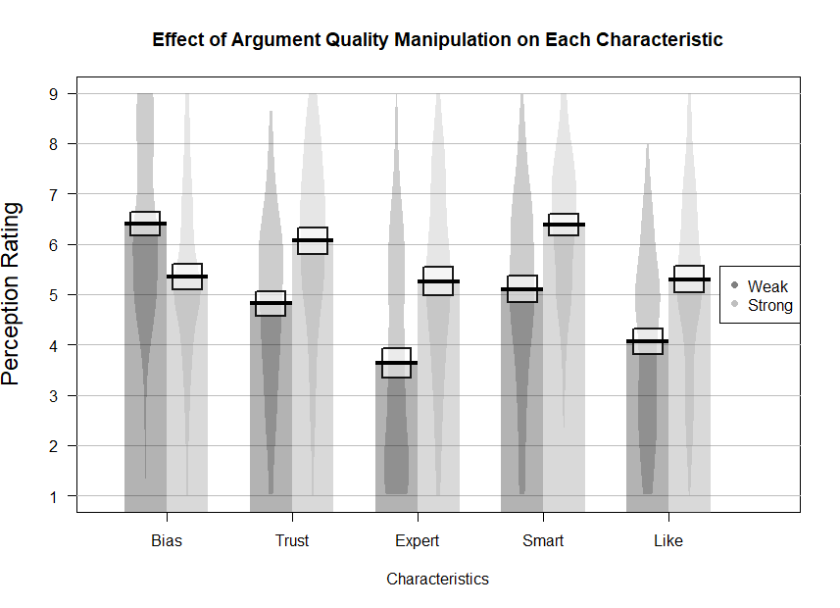

Argument Quality Effects on Source Perceptions in Studies 2-9

Table S8. Effects of argument quality, pre-message attitudes, and other perceptions on each perception in Studies 2, 4, 5, and 6 (combined)
 | bias |  |  | trust |  |  | expert
 | b | t | p | b | t | p | b | t | p
Arg. Quality only | -.78 | -12.73 | < .001 | .59 | 9.50 | < .001 | .81 | 11.92 | < .001
Arg. Quality with cov. | -.35 | -6.06 | < .001 | .04 | .67 | .50 | .24 | 4.24 | < .001
Post-message Attitudes | .17 | 6.49 | <.001 | -.04 | -1.69 | .09 | -.07 | -2.74 | .006
Bias | - | - | - | -.18 | -5.40 | < .001 | -.25 | -7.10 | < .001
Trustworthiness | -.21 | -5.40 | < .001 | - | - | - | .56 | 16.71 | < .001
Expertise | -.26 | -7.10 | < .001 | .49 | 16.71 | <.001 | - | - | -

Table S9. Effects of argument quality, pre-message attitudes, and other perceptions on each perception in Studies 3, 7, 8, and 9 (combined)
 | bias |  |  | trust |  |  |  | expert |  |  |  | smart |  |  | like
 | b | t | p |  | b | t | p |  | b | t | p | b | t | p |  | b | t | p
Arg. Quality only | -.63 | -11.27 | < .001 |  | .47 | 8.46 | < .001 |  | .71 | 11.60 | < .001 | .61 | 10.32 | < .001 |  | .53 | 9.23 | < .001
Arg. Quality with cov | -.32 | -5.75 | < .001 |  | -.01 | -.11 | .91 |  | .21 | 4.33 | <.001 | .08 | 1.66 | .10 |  | .00 | .06 | .95
Attitudes | .11 | 4.44 | < .001 |  | -.04 | -2.08 | .04 |  | .01 | .55 | .59 | -.05 | -2.32 | .02 |  | -.03 | -1.38 | .17
Bias | - | - | - |  | -.03 | -1.02 | .31 |  | -.10 | -3.13 | .002 | -.07 | -2.43 | .02 |  | -.08 | -3.06 | .002
Trustworthiness | -.05 | -1.02 | .31 |  | - | - | - |  | .38 | 9.85 | < .001 | .01 | .23 | .82 |  | .38 | 11.82 | < .001
Expertise | -.13 | -3.13 | .002 |  | .30 | 9.85 | < .001 |  | - | - | - | .32 | 10.15 | < .001 |  | .05 | 1.72 | .09
Smart | -.11 | -2.43 | .02 |  | .01 | .23 | .82 |  | .38 | 10.15 | < .001 | - | - | - |  | .39 | 12.87 | < .001
Like | -.15 | -3.06 | .002 |  | .41 | 11.82 | < .001 |  | .07 | 1.72 | .09 | .46 | 12.87 | < .001 |  | - | - | -

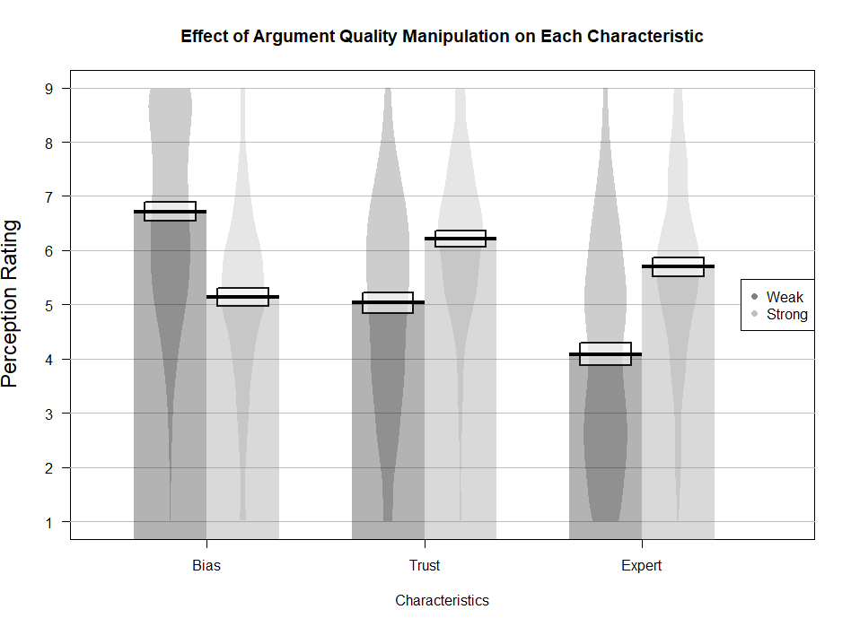
Figure S11. Effects of the argument quality manipulation on each of the perceptions in Studies 2, 4, 5, and 6 (combined). The solid horizontal line represents the mean of each condition, the box around it represents 95% confidence intervals and the smooth density curve shows the data distribution.
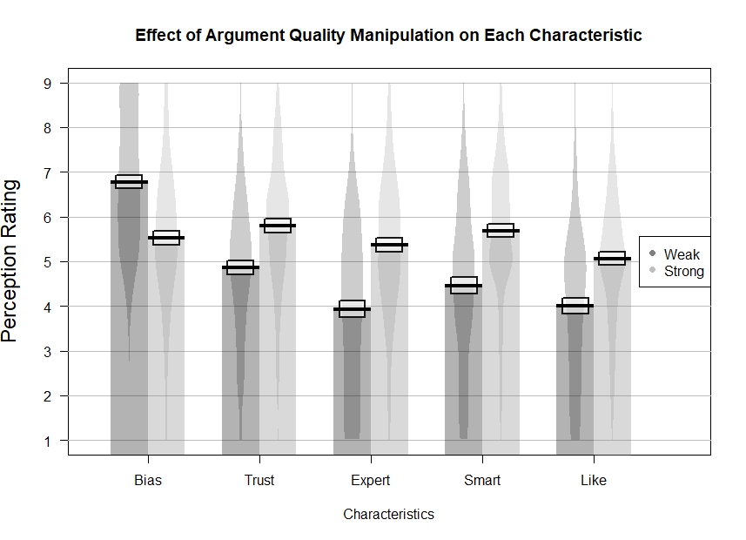
Figure S12. Effects of the argument quality manipulation on each of the perceptions in Studies 3, 7, 8, and 9 (combined). The solid horizontal line represents the mean of each condition, the box around it represents 95% confidence intervals and the smooth density curve shows the data distribution.

Perceived Bias Carry-Over: Backend of Studies 6, 7, and 8
We regressed perceived bias after the second message on (centered) perceived bias after the first message, the argument quality of the second message, and their interaction (Figure S4). Additionally, we included pre-message attitudes as a predictor. Replicating results from the first part of the studies, argument quality, b = -.82, t(595) = -10.84, p < .001, 95% CI [-.97, -.67], r = -.41 significantly influenced perceived bias. Furthermore, pre-message attitudes continued to predict perceived bias, b = -.13, t(595) = -3.99, p < .001, 95% CI [-.19, -.06], r = -.16. Initial perceived bias, b = .14, t(595) = 3.50, p < .001, 95% CI [.06, .21], r = .14, also predicted post-message perceived bias, suggesting carry-over from one message to another. Interestingly, an interaction between perceived bias and time 2 argument quality qualified these main effects, b = -.10, t(595) = -2.65, p = .008, 95% CI [-.18, -.03], r = -.11. Although participants used the second message argument quality to inform their bias judgments both when they saw the source as relatively more (+1 SD from the mean), b = -1.02, t(595) = -9.52, p < .001, 95% CI [-1.23, -.81], r = -.36, and less biased (-1 SD from the mean), b = -.62, t(595) = -5.79, p < .001, 95% CI [-.83, -.41], r = -.23, initially, they did this to a greater extent when they initially viewed Cami as relatively biased. This result was consistent with our hypothesis that initially seeing a source as biased can enhance the extent to which recipients use message content to test whether the source is also biased on the new topic. Importantly, these effects are not supported when using an index of perceived bias that only include that two perceived bias items to these results should be interpreted with caution.

Influences of Source Bias on Persuasion on a New Topic: Backend of Study 9

Effects of source bias on thoughts. We conducted a GLM regressing post-message thoughts on argument quality in the second message (weak, mixed, or strong), initial perceived bias as a continuous predictor, and their interaction, as well as pre-message attitudes as a covariate. For this analysis, we used participant-coded thoughts, though the pattern is identical for research-assistant-coded thoughts (see Supplemental Materials). As one would expect, pre-message attitudes significantly predicted post-message thoughts, F(1, 198) = 9.18, p = .003, η²_{p} = .04. Argument quality had a main effect, F(2, 198) = 4.64, p = .01, η²_{p} = .05, but perceived bias did not, F(1, 198) = 1.71, p = .19, η²_{p} = .01. Most importantly, there was a significant interaction between time 2 argument quality and initial perceived bias, F(2, 198) = 6.96, p = .001, η²_{p} = .07. This pattern on the two omnibus (>1 df) tests could be consistent with the expectation that perceived bias will primarily affect post-message thoughts in the mixed-argument condition.
To probe the interaction pattern, we contrast coded argument quality, with the first argument quality variable (AQ-SW) comparing the strong condition to the weak condition (strong = 1, weak = -1, mixed = 0). The second argument quality variable (AQ-Mixed) compared the mixed condition to the strong and weak conditions (strong = 1, weak = 1, mixed = -2). Both argument quality variables were entered into a mean-centered regression with initial perceived bias and each of the resulting two-way interactions predicting post-message thoughts. We also controlled for pre-message attitudes. In this model, the key interaction between perceived bias and “mixed” argument quality was significant, b = .07, t(198) = 3.38, p < .001, 95% CI [.03, .11], r = .23. Source bias had a significant effect on thoughts when participants read the mixed message, b = -.18, t(198) = -3.56, p < .001, 95% CI [-.28, -.08], r = -.25, but not when they read the clearly weak, b = -.02, t(198) = -.35, p = .73, 95% CI [-.11, .08], r = -.02, or strong arguments, b = .08, t(198) = 1.66, p = .10, 95% CI [-.01, .17], r = .12. The source bias effect on thoughts was significantly greater in the mixed compared to the strong, b = -.13, t(132) = -3.62, p = .0004, 95% CI [-.21, -.06], r = .30, or the weak conditions, b = -.08, t(134) = -2.23, p = .03, 95% CI [-.15, -.01], r = -.19. Thus, the influences on thoughts were most consistent with negatively biased processing when the message was mixed rather than clearly strong or weak.
Moderated mediation analyses on post-message attitudes. To more directly test the primary hypothesis that perceiving a source as biased would lead people to process the message more negatively, and therefore reduce persuasion when arguments are ambiguously strong, we used PROCESS (Hayes, 2013) to test a moderated mediation model (Model 10) in which perceived bias would lead to more negative thoughts about the message when people heard the mixed arguments, but not when they heard the strong or weak arguments. The negative thoughts generated in the mixed argument condition would then lead to more negative attitudes. Consistent with previous analyses, we statistically controlled for pre-message attitudes. Across all three argument quality conditions, the total effect of perceived bias on thoughts was not significant. However, source bias had a significant effect on thoughts when participants received the mixed message.
In a model with pre-message perceived bias, the argument quality variables, the corresponding two-way interactions, thoughts, and pre-message attitudes predicting post-message attitudes, thoughts influenced post-message attitudes, b = 1.88, t(197) = 9.64, p < .001, 95% CI [1.49, 2.26], r = .57, suggesting high elaboration. Pre-message attitudes also influenced post-message attitudes, b = .63, t(197) = 11.79, p < .001, 95% CI [.52, .73], r = .64, and none of the other effects in the model were significant, ps>.16, consistent with a mediation pattern.
The moderated indirect effect of perceived source bias through thought unfavorability was tested using 10,000 bootstrapped samples (Figure S13). The indirect effect was significant in the mixed argument condition, b = -.34, 95% CI [-.55, -.12], but not the strong argument condition, b = .15, 95% CI [-.02, .33], or the weak argument condition, b = -.03, 95% CI [-.19, .13]. Consistent with this, the index of moderated mediation was significant when comparing the mixed condition to the weak and strong conditions, index = .39, 95% CI [.15, .66], but not when comparing the strong and weak conditions, index = .11, 95% CI [-.01, .25]. These findings suggest that when the quality of a message is ambiguous, having formed a previous perception that the source is biased can result in directional processing of a new message on a different topic such that people think about the new message more negatively than they otherwise would have and are therefore less persuaded.
Figure S13. Effect of initial (pre-message) perceived bias on post-message attitudes mediated through thoughts and at each level of argument quality. Total effects are in parentheses.
†p < .10, *p < .05, **p < .01 ***p < .001

These effects were unchanged when controlling for perceived trustworthiness and expertise, the alternative perceptions measured in all of these studies: initial perceived bias x time 2 argument quality interaction, b = -.11, t(587) = -2.77, p = .006.

