Supplemental Materials for Prototypes of Source Characteristics
Contents
Tables with all of the attributes generated in Study 1 2
All of the attributes generated for (dis)likeability 2
All of the attributes generated for (un)trustworthiness 3
All of the attributes generated for (in)expertise 4
All of the attributes generated for power(less) 5
Tables with the mean ratings of the four characteristics for each attribute 6
Table with ratings of the four characteristics for (dis)likeable attributes 6
Table with ratings of the four characteristics for (un)trustworthy attributes 7
Table with ratings of the four characteristics for (in)expert attributes 8
Table with ratings of the four characteristics for power(less) attributes 9
Separate Results for each of the sets of likeability traits in Study 3 10
Moderation by Gender and Age in Studies 2 and 3 12
Moderation by Gender in Study 2 Liking Description Set 12
Moderation by Age in Study 2 Liking Description Set 13
sModeration by Gender in Study 2 Trustworthiness Description Set 14
Moderation by Age in Study 2 Trustworthiness Description Set 15
Moderation by Gender in Study 2 Expertise Description Set 16
Moderation by Age in Study 2 Expertise Description Set 17
Moderation by Gender in Study 2 Powerfulness Description Set 18
Moderation by Age in Study 2 Powerful Description Set 19
Moderation by Gender in Study 3 20
Moderation by Age in Study 3 21
Attributes generated for each characteristic graphed along each possible pair of characteristics 26

Tables with all of the attributes generated in Study 1

All of the attributes generated for (dis)likeability
Likeable |  |  |  | Dislikeable
Attribute | M | SD | # generating | Attribute | M | SD | # generating
Caring | 6.74 | 1.00 | 2 | Rude | 7.23 | 1.13 | 9
Kind | 6.58 | 1.35 | 4 | Cruel | 7.30 | 1.35 | 1
Genuine | 6.56 | 1.44 | 3 | Arrogant | 6.79 | 1.54 | 3
Friendly | 6.56 | 1.40 | 8 | Racist | 6.67 | 1.86 | 1
Nice | 6.26 | 1.16 | 3 | Mean | 6.60 | 1.53 | 3
Pleasant | 6.37 | 1.25 | 2 | Discriminatory | 6.60 | 1.68 | 1
Sincere | 6.37 | 1.33 | 1 | Hostile | 6.53 | 1.58 | 1
Considerate | 6.23 | 1.00 | 1 | Manipulative | 6.56 | 1.76 | 1
Helpful | 6.30 | 1.08 | 1 | Abrasive | 6.56 | 1.68 | 2
Warm | 6.21 | 1.37 | 1 | Impolite | 6.49 | 1.42 | 2
Empathetic | 6.12 | 1.29 | 1 | Disrespectful | 6.42 | 1.53 | 2
Respectful | 6.05 | 1.51 | 1 | Intolerable | 6.49 | 1.45 | 1
Supportive | 5.98 | 1.22 | 1 | Repelling | 6.28 | 1.78 | 1
Welcoming | 5.91 | 1.13 | 1 | Conniving | 6.49 | 1.88 | 1
Amiable | 5.88 | 1.37 | 1 | Nasty | 6.35 | 1.69 | 1
Positive | 5.81 | 1.64 | 4 | Condescending | 6.30 | 1.60 | 2
Cooperative | 5.79 | 1.39 | 1 | Intolerant | 6.33 | 1.57 | 1
Generous | 5.67 | 1.30 | 1 | Unkind | 6.33 | 1.58 | 1
Humble | 5.84 | 1.23 | 1 | Offensive | 6.21 | 1.74 | 1
Unselfish | 5.63 | 1.72 | 1 | Sexist | 6.19 | 1.89 | 1
Non-Threatening | 5.65 | 1.54 | 3 | Unfriendly | 6.12 | 1.65 | 3
Accommodating | 5.63 | 1.36 | 1 | Selfish | 6.16 | 1.72 | 1
Easy-going | 5.60 | 1.20 | 1 | Aggressive | 6.07 | 1.91 | 1
Fun | 5.49 | 1.91 | 1 | Uncaring | 6.02 | 1.54 | 1
Engaging | 5.40 | 1.64 | 1 | Obnoxious | 5.86 | 1.91 | 1
Receptive | 5.35 | 1.70 | 1 | Unpleasant | 5.81 | 1.65 | 2
Pleasing | 5.35 | 1.66 | 2 | Confrontational | 5.88 | 1.78 | 2
Reassuring | 5.30 | 1.35 | 1 | Pushy | 5.81 | 1.48 | 4
Agreeable | 5.26 | 1.51 | 1 | Negative | 5.67 | 2.01 | 1
Relatable | 5.37 | 1.77 | 1 | Creepy | 5.67 | 2.03 | 1
Sociable | 5.33 | 1.60 | 4 | Angry | 5.70 | 2.06 | 1
Contributive | 5.16 | 1.73 | 1 | Forceful | 5.58 | 2.05 | 1
Charming | 5.16 | 1.70 | 1 | Uninviting | 5.58 | 1.67 | 1
Charismatic | 4.98 | 1.99 | 1 | Argumentative | 5.63 | 2.00 | 1
Happy | 5.02 | 1.85 | 2 | Annoying | 5.49 | 1.44 | 1
Open | 4.88 | 1.53 | 3 | Distasteful | 5.49 | 2.03 | 1
Affection | 4.74 | 1.63 | 1 | Uncourteous | 5.49 | 1.98 | 1
Outgoing | 4.51 | 1.80 | 1 | Dismissive | 5.40 | 1.89 | 1
Relaxed | 4.58 | 2.00 | 2 | Disagreeable | 5.35 | 1.93 | 1
Ebullient | 4.07 | 1.58 | 1 | Unpalatable | 5.26 | 1.93 | 1
Soft-Spoken | 3.63 | 2.01 | 1 | Irrational | 5.28 | 2.12 | 1
 |  |  |  | Interruptive | 5.21 | 1.85 | 1
 |  |  |  | Crude | 5.12 | 2.13 | 1
 |  |  |  | Frustrating | 5.12 | 1.99 | 1
 |  |  |  | Brash | 5.14 | 1.95 | 1
 |  |  |  | Irritable | 5.00 | 1.79 | 1
 |  |  |  | Dirty | 4.88 | 2.12 | 1
 |  |  |  | Superior | 4.81 | 2.01 | 1
 |  |  |  | Unacceptable | 4.81 | 2.01 | 1
 |  |  |  | Narrow | 4.40 | 1.83 | 1
 |  |  |  | Smelly | 4.35 | 2.08 | 1
 |  |  |  | Controversial | 4.26 | 2.04 | 1
 |  |  |  | Loud | 4.23 | 1.90 | 2
 |  |  |  | Aloof | 3.74 | 2.01 | 1
 |  |  |  | Blunt | 3.79 | 1.96 | 1
 |  |  |  | Flawed | 3.07 | 1.87 | 1
 |  |  |  | Ugly | 2.42 | 1.58 | 1

All of the attributes generated for (un)trustworthiness
Trustworthy |  |  |  | Untrustworthy
Attribute | M | SD | # generating | Attribute | M | SD | # generating
Honest | 7.29 | 0.94 | 14 | Deceitful | 7.45 | 1.04 | 1
Sincere | 6.76 | 1.38 | 3 | Dishonest | 7.34 | 1.26 | 4
Reliable | 6.60 | 1.37 | 9 | Scheming | 7.19 | 1.31 | 1
Dependable | 6.49 | 1.43 | 10 | Unreliable | 7.06 | 1.21 | 9
Believable | 6.40 | 1.74 | 1 | Shady | 6.96 | 1.46 | 1
Reputable | 6.41 | 1.40 | 1 | Undependable | 6.81 | 1.39 | 2
Safe | 5.44 | 1.67 | 1 | Unaccountable | 6.70 | 1.23 | 1
Consistent | 5.49 | 1.65 | 2 | Insincere | 6.43 | 1.63 | 1
Aboveboard | 5.27 | 2.46 | 1 | Inconsistent | 6.43 | 1.63 | 3
Compassionate | 4.98 | 1.92 | 2 | Fake | 6.45 | 1.85 | 1
Open | 5.18 | 1.58 | 1 | Unbelievable | 6.47 | 1.86 | 1
Well-Meaning | 4.86 | 1.84 | 1 | Sketchy | 6.32 | 1.60 | 2
Nice | 4.44 | 2.11 | 1 | Shifty | 6.28 | 1.51 | 2
Logical | 4.49 | 2.18 | 1 | Withholding | 6.38 | 1.51 | 1
Comfortable | 3.51 | 2.20 | 1 | Artificial | 6.04 | 1.84 | 1
Clean | 3.31 | 2.19 | 1 | Cruel | 5.47 | 2.37 | 1
Well-Dressed | 2.88 | 2.09 | 1 | Lazy | 4.45 | 2.00 | 1

All of the attributes generated for (in)expertise
Expert |  |  |  | Inexpert
Attribute | M | SD | # generating | Attribute | M | SD | # generating
Knowledgeable | 7.29 | 1.01 | 27 | Unqualified | 6.27 | 2.27 | 3
Experienced | 7.20 | 1.10 | 12 | Inexperienced | 6.24 | 1.98 | 12
Qualified | 7.02 | 1.19 | 7 | Unintelligent | 5.98 | 2.12 | 1
Mastered | 6.85 | 1.41 | 1 | Uninformed | 5.83 | 2.34 | 1
Skillful | 6.85 | 1.11 | 1 | Untrained | 5.83 | 2.31 | 1
Competent | 6.76 | 1.18 | 1 | Stupid | 5.49 | 2.28 | 1
Trained | 6.66 | 1.28 | 4 | Amateur | 5.39 | 2.12 | 1
Practiced | 6.63 | 1.13 | 2 | Inadequate | 5.39 | 2.17 | 1
Informed | 6.59 | 1.40 | 1 | Wrong | 5.37 | 2.29 | 2
Educated | 6.51 | 1.25 | 7 | Unprofessional | 5.34 | 2.08 | 4
Professional | 6.51 | 1.25 | 1 | Uneducated | 5.24 | 2.18 | 2
Reputable | 6.49 | 1.12 | 2 | Unfamiliar | 5.02 | 2.20 | 1
Accomplished | 6.46 | 1.48 | 1 | Unstudied | 5.02 | 2.25 | 1
Smart | 6.41 | 1.41 | 1 | Inconsistent | 4.83 | 2.20 | 1
Studious | 6.41 | 1.40 | 1 | Average | 4.76 | 1.91 | 1
Proven | 6.37 | 1.46 | 1 | Vague | 4.66 | 1.91 | 1
Demonstrated | 6.22 | 1.54 | 1 | Informal | 3.66 | 2.16 | 1
Fluent | 6.17 | 1.61 | 1 | Emotional | 3.44 | 1.98 | 1
Resourceful | 6.12 | 1.47 | 1 | Unsophisticated | 3.34 | 2.09 | 1
Trustworthy | 6.00 | 1.84 | 2
Confident | 5.93 | 1.92 | 4
Analytical | 5.90 | 1.48 | 1
Convincing | 5.73 | 1.70 | 1
Published | 5.66 | 1.70 | 1
Objective | 5.61 | 1.81 | 3
Authoritative | 5.22 | 2.12 | 2
Intuitive | 4.88 | 2.10 | 2
Passionate | 4.83 | 2.18 | 1
Comfortable | 4.44 | 2.40 | 1
Calm | 4.02 | 2.40 | 1

All of the attributes generated for power(less)
Powerful |  |  |  | Powerless
Attribute | M | SD | # generating | Attribute | M | SD | # generating
In Charge | 7.08 | 1.05 | 1 | Dependent | 6.78 | 1.21 | 1
Influential | 6.98 | 1.14 | 9 | Helpless | 6.65 | 1.39 | 1
Dominant | 6.75 | 1.08 | 2 | No Choice | 6.65 | 1.55 | 1
Assertive | 6.60 | 1.08 | 1 | Weak | 6.65 | 1.66 | 1
Persuasive | 6.58 | 1.01 | 3 | no free will | 6.63 | 1.69 | 1
Wealthy | 6.25 | 1.81 | 4 | No Say | 6.58 | 1.96 | 1
Charismatic | 6.13 | 1.54 | 1 | Lacking confidence | 6.50 | 1.45 | 1
Achieving | 6.08 | 1.37 | 1 | Ignored | 6.48 | 1.54 | 1
Strong | 6.00 | 1.45 | 3 | Defenseless | 6.45 | 1.58 | 1
Expert | 5.88 | 1.52 | 1 | Will-less | 6.38 | 1.69 | 1
Forceful | 5.78 | 1.79 | 1 | Unsuccessful | 6.33 | 1.49 | 1
Resourceful | 5.75 | 1.60 | 1 | No strength | 6.20 | 1.79 | 1
Causing Fear | 5.73 | 1.75 | 1 | Ineffective | 6.13 | 1.73 | 1
Demanding | 5.70 | 1.59 | 1 | Unheard | 5.85 | 1.97 | 1
Accommodated | 5.45 | 1.77 | 1 | Hopeless | 5.75 | 1.81 | 1
Purposeful | 5.45 | 1.55 | 1 | Poor | 5.70 | 2.07 | 1
Intellectual | 5.38 | 1.72 | 1 | Clueless | 5.58 | 1.84 | 1
Not Afraid | 5.38 | 1.67 | 1 | Not Knowledgeable | 5.55 | 1.81 | 1
Responsible | 5.38 | 1.96 | 1 | Afraid | 5.40 | 1.84 | 1
Scary | 5.38 | 1.86 | 1 | Inhibited | 5.40 | 1.68 | 1
Able | 5.35 | 1.67 | 1 | Anxious | 5.33 | 1.97 | 1
Admirable | 5.03 | 1.72 | 1 | Invalid | 5.25 | 2.05 | 1
Aware | 4.73 | 2.14 | 1 | Despairful | 5.23 | 1.97 | 1
Energetic | 4.70 | 2.11 | 1 | No help | 5.10 | 2.13 | 1
Big | 4.55 | 1.81 | 1 | Apathetic | 4.93 | 1.91 | 1
Well-Dressed | 4.50 | 2.08 | 1 | Non-threatening | 4.93 | 1.97 | 1
Booming | 4.45 | 2.09 | 1 | malaise | 4.70 | 1.95 | 1
Angry | 4.00 | 2.22 | 1 | Disappointed | 4.50 | 2.29 | 1
Fast-talking | 3.75 | 1.72 | 1 | Simple | 4.50 | 2.08 | 1
Relaxed | 3.20 | 1.68 | 1 | Depressed | 4.33 | 2.13 | 1
 |  |  |  | Argumentative | 4.23 | 1.93 | 1
 |  |  |  | Irrational | 4.20 | 2.21 | 1
 |  |  |  | Silent | 4.18 | 2.05 | 1
 |  |  |  | Sad | 4.08 | 2.07 | 1
 |  |  |  | Unjustified | 4.08 | 2.16 | 1
 |  |  |  | Stressed | 4.00 | 2.20 | 1
 |  |  |  | Poorly dressed | 3.95 | 1.80 | 1
 |  |  |  | Tired | 3.75 | 2.26 | 1
 |  |  |  | Obvious | 3.65 | 1.89 | 1
 |  |  |  | Repetitive | 3.43 | 1.89 | 1

Tables with the mean ratings of the four characteristics for each attribute

Table with ratings of the four characteristics for (dis)likeable attributes
Attribute | Likeable | Trustworthy | Expert | Powerful
Caring | 5.57 | 5.33 | 4.41 | 4.24
Kind | 5.57 | 5.03 | 4.17 | 4.24
Friendly | 5.55 | 4.86 | 4.09 | 4.07
Fun | 5.49 | 4.27 | 3.88 | 3.98
Generous | 5.49 | 5.14 | 4.31 | 4.45
Warm | 5.48 | 4.97 | 4.17 | 4.02
Considerate | 5.47 | 5.08 | 4.45 | 4.27
Welcoming | 5.45 | 4.86 | 4.12 | 4.43
Genuine | 5.41 | 5.45 | 4.62 | 4.45
Sincere | 5.40 | 5.45 | 4.52 | 4.36
Nice | 5.40 | 4.88 | 4.02 | 3.95
Positive | 5.39 | 5.06 | 4.57 | 4.78
Pleasant | 5.39 | 4.86 | 4.20 | 4.27
Supportive | 5.36 | 5.09 | 4.31 | 4.22
Humble | 5.36 | 5.12 | 4.38 | 3.98
Respectful | 5.31 | 5.12 | 4.50 | 4.40
Cooperative | 5.31 | 4.96 | 4.35 | 4.20
Helpful | 5.26 | 4.95 | 4.60 | 4.40
EasyGoing | 5.24 | 4.43 | 3.84 | 3.53
Empathetic | 5.24 | 4.91 | 4.16 | 4.31
Unselfish | 5.24 | 5.22 | 4.12 | 4.00
Amiable | 5.16 | 4.81 | 4.12 | 3.95
Accomodating | 5.14 | 4.67 | 3.93 | 3.81
Engaging | 5.10 | 4.59 | 4.67 | 4.84
Nonthreatening | 4.64 | 4.43 | 3.71 | 3.26
Forceful | 2.26 | 2.69 | 3.22 | 4.26
Aggressive | 2.14 | 2.52 | 3.28 | 4.10
Angry | 2.00 | 2.41 | 2.78 | 3.29
Argumentative | 2.00 | 2.65 | 3.14 | 3.51
Uninviting | 1.98 | 2.33 | 2.88 | 3.00
Abrasive | 1.88 | 2.60 | 3.00 | 3.34
Pushy | 1.86 | 2.37 | 3.00 | 3.71
Negative | 1.86 | 2.55 | 2.78 | 2.59
Intolerant | 1.74 | 2.12 | 2.45 | 2.90
Sexist | 1.74 | 1.95 | 2.24 | 2.67
Conniving | 1.74 | 1.60 | 2.88 | 3.45
Impolite | 1.71 | 2.39 | 2.78 | 2.92
Unpleasant | 1.71 | 2.33 | 2.66 | 3.14
Intolerable | 1.71 | 2.07 | 2.66 | 3.00
Unfriendly | 1.67 | 2.16 | 2.76 | 2.69
Repelling | 1.67 | 2.14 | 2.62 | 2.62
Uncaring | 1.65 | 1.90 | 2.84 | 2.96
Selfish | 1.65 | 1.76 | 2.82 | 3.35
Discriminatory | 1.64 | 1.90 | 2.29 | 3.12
Arrogant | 1.63 | 2.37 | 3.10 | 3.49
Condescending | 1.61 | 2.20 | 3.02 | 3.06
Confrontational | 1.59 | 2.33 | 2.78 | 3.47
Unkind | 1.57 | 1.84 | 2.61 | 2.73
Hostile | 1.57 | 2.05 | 2.81 | 3.33
Offensive | 1.51 | 2.06 | 2.29 | 2.94
Rude | 1.51 | 2.29 | 2.61 | 2.90
Nasty | 1.43 | 1.78 | 2.26 | 2.64
Creepy | 1.41 | 1.82 | 2.57 | 2.61
Manipulation | 1.39 | 1.41 | 2.69 | 3.84
Obnoxious | 1.37 | 2.08 | 2.49 | 2.33
Disrespectful | 1.35 | 1.76 | 2.29 | 2.47
Racist | 1.35 | 1.63 | 1.92 | 2.57
Mean | 1.33 | 1.88 | 2.41 | 3.06
Cruel | 1.28 | 1.47 | 2.24 | 3.09

Table with ratings of the four characteristics for (un)trustworthy attributes
Attribute | Likeable | Trustworthy | Expert | Powerful
Honest | 5.49 | 5.64 | 4.44 | 4.51
Dependable | 5.34 | 5.43 | 4.61 | 4.46
Reliable | 5.18 | 5.41 | 4.49 | 4.56
Sincere | 5.30 | 5.34 | 4.18 | 4.20
Reputable | 4.82 | 5.11 | 4.93 | 4.79
Believable | 4.97 | 5.07 | 4.44 | 4.38
Safe | 4.75 | 5.03 | 3.93 | 3.93
Artificial | 2.03 | 1.93 | 2.66 | 2.79
Inconsistent | 2.26 | 1.92 | 2.25 | 2.48
Withholding | 2.07 | 1.89 | 2.66 | 2.90
Unbelievable | 2.23 | 1.66 | 2.26 | 2.48
Insincere | 1.72 | 1.62 | 2.44 | 2.66
Shifty | 1.85 | 1.62 | 2.44 | 2.75
Unaccountable | 1.93 | 1.57 | 2.05 | 2.49
Unreliable | 1.90 | 1.44 | 1.97 | 2.11
Undependable | 1.89 | 1.46 | 2.11 | 2.02
Scheming | 1.57 | 1.36 | 2.52 | 3.16
Sketchy | 1.72 | 1.36 | 2.03 | 2.38
Shady | 1.61 | 1.36 | 2.30 | 2.49
Fake | 1.41 | 1.26 | 1.77 | 2.49
Dishonest | 1.43 | 1.16 | 2.10 | 2.52
Deceitful | 1.34 | 1.16 | 2.44 | 2.92

Table with ratings of the four characteristics for (in)expert attributes
Attribute | Likeable | Trustworthy | Expert | Powerful
Mastered | 4.67 | 5.07 | 5.46 | 5.13
Knowledgeable | 4.75 | 5.03 | 5.34 | 4.87
Accomplished | 4.72 | 4.98 | 5.28 | 5.05
Qualified | 4.51 | 4.89 | 5.20 | 4.69
Educated | 4.59 | 4.70 | 5.15 | 4.77
Smart | 4.66 | 4.48 | 5.11 | 4.89
Skillful | 4.61 | 4.61 | 5.11 | 4.79
Experienced | 4.46 | 4.80 | 5.11 | 4.67
Professional | 4.64 | 4.92 | 5.07 | 4.92
Proven | 4.77 | 5.15 | 5.08 | 4.84
Competent | 4.74 | 4.80 | 4.95 | 4.62
Reputable | 4.79 | 5.15 | 4.92 | 4.92
Published | 4.26 | 4.62 | 4.89 | 4.54
Confident | 4.77 | 4.49 | 4.48 | 4.75
Informed | 4.28 | 4.59 | 4.84 | 4.48
Trained | 4.30 | 4.54 | 4.67 | 4.43
Analytical | 4.13 | 4.57 | 4.70 | 4.48
Resourceful | 4.66 | 4.61 | 4.66 | 4.93
Fluent | 4.46 | 4.41 | 4.67 | 4.38
Demonstrated | 4.43 | 4.64 | 4.64 | 4.46
Studious | 4.56 | 4.56 | 4.64 | 4.33
Practiced | 4.30 | 4.31 | 4.62 | 4.33
Trustworthy | 5.38 | 5.84 | 4.56 | 4.74
Objective | 4.30 | 4.56 | 4.39 | 4.21
Convincing | 4.30 | 3.92 | 4.34 | 4.80
Inexperienced | 3.20 | 2.75 | 1.82 | 2.30
Uninformed | 2.82 | 2.38 | 1.77 | 2.16
Unintelligent | 2.79 | 2.36 | 1.64 | 1.84
Untrained | 2.98 | 2.59 | 1.59 | 2.30
Unqualified | 2.97 | 2.59 | 1.57 | 2.16
Stupid | 2.41 | 2.15 | 1.46 | 1.77

Table with ratings of the four characteristics for power(less) attributes
Attribute | Likeable | Trustworthy | Expert | Powerful
Strong | 4.47 | 4.25 | 4.22 | 5.22
Influential | 4.22 | 4.00 | 4.40 | 5.11
Dominant | 3.15 | 3.33 | 3.89 | 5.07
Wealthy | 3.65 | 3.38 | 3.89 | 4.96
Resourceful | 4.66 | 4.61 | 4.66 | 4.93
Assertive | 3.91 | 3.91 | 4.20 | 4.75
Expert | 4.40 | 4.75 | 5.55 | 4.75
Achieving | 4.40 | 4.44 | 4.82 | 4.73
Forceful | 2.26 | 2.69 | 3.22 | 4.26
Charismatic | 4.71 | 3.82 | 4.09 | 4.62
Persuasive | 4.07 | 3.49 | 4.13 | 4.55
Causing Fear | 1.89 | 2.05 | 2.85 | 3.93
Demanding | 2.58 | 3.13 | 3.56 | 3.91
Dependent | 3.40 | 3.45 | 2.95 | 2.45
Poor | 3.51 | 3.40 | 2.91 | 2.25
Not Knowledgeable | 3.00 | 2.40 | 1.47 | 2.20
Unsuccessful | 2.85 | 2.75 | 2.25 | 2.13
No Choice | 3.16 | 2.84 | 2.73 | 2.07
Ineffective | 2.64 | 2.67 | 2.25 | 2.04
Ignored | 2.93 | 3.18 | 2.96 | 2.02
Unheard | 3.29 | 3.24 | 2.95 | 1.98
Lacking Control | 2.71 | 2.49 | 2.55 | 1.96
Clueless | 2.42 | 2.22 | 1.51 | 1.91
Hopeless | 2.67 | 2.62 | 2.44 | 1.89
Will Less | 2.75 | 2.58 | 2.51 | 1.89
Weak | 3.02 | 3.05 | 2.62 | 1.78
No Say | 3.13 | 2.98 | 2.64 | 1.75
No Strength | 3.02 | 3.00 | 2.58 | 1.71
Defenseless | 3.45 | 3.33 | 2.82 | 1.67
Helpless | 3.38 | 3.13 | 2.44 | 1.64
No Free Will | 2.82 | 2.29 | 2.38 | 1.58

Separate Results for each of the sets of likeability traits in Study 3

Relative influences on perceptions of “intended” than “unintended” traits. Because different sets of participants responded to each set of likeability descriptions, we analyzed the two groups of descriptions separately to supplement the analyses in the text in which they were analyzed together. Results for the first and second set are presented here. Among those descriptions generated for the first and second set of (dis)likeability descriptions, the key interaction between valence and the trait measures was significant, F(3, 55) = 80.28, p < .001; F(3, 46) = 52.55, p < .001. To test whether this interaction was due to the difference between the positive and negative descriptions better predicting the difference between likeability and dislikeability more so than each of the other traits, we ran three two-way mixed GLMs comparing likeability to each of the other characteristics. The difference between the positive and the negative descriptions was greater for the ratings of likeability (M = 5.30 vs. M = 1.77; M = 5.39 vs. M = 1.58) than trustworthiness (M = 5.00 vs. M = 2.13; M = 4.86 vs. M = 2.08; Valence X Characteristic Rating, F(1, 57) = 101.05, p < .001; F(1, 48) = 91.77, p < .001), expertise (M = 4.23 vs. M = 2.68; M = 4.28 vs. M = 2.68; Valence X Characteristic Rating, F(1, 57) = 183.41, p < .001; F(1, 48) = 136.94, p < .001), or power (M = 4.09 vs. M = 3.20; M = 4.30 vs. M = 3.01; F(1, 57) = 192.88, p < .001; F(1, 48) = 146.94, p < .001), indicating that the descriptions generated to describe likeability did indeed predict likeability better than the other characteristics. There were also significant main effects of the trait measures, F(3, 55) = 4.74, p = .005; F(3, 46) = 4.85, p = .005, and valence, F(1, 57) = 396.50, p < .001; F(1, 48) = 255.74, p < .001.
Identifying the most likely confounds across traits. The difference that the (dis)likability descriptions created in trustworthiness was larger than expertise, F(1, 57) = 85.95, p < .001 (set 1); F(1, 48) = 67.61, p < .001 (set 2), or power, F(1, 57) = 109.92, p < .001 (set 1); F(1, 48) = 69.57, p < .001 (set 2), in both sets of liking descriptions.

Moderation by Gender and Age in Studies 2 and 3

Moderation by Gender in Study 2 Liking Description Set

To test whether men and women provided different informativeness ratings of the descriptions of liking, we examined a mixed GLM in which the 98 descriptions were a within subjects factor and gender was a between subjects factor. For this analysis and all of these Study 2 moderation by demographics moderation analyses, we used a univariate test because the large number of within-subject levels of the trait measure made multivariate analyses impossible. In this model there was not a significant main effect of gender, F(1, 41) = .54, p = .47, suggesting that men and women overall reported relatively similar levels of informativeness. There was a main effect of descriptions, F(97, 3977) = 14.59, p < .001, consistent with the idea that some descriptions were more informative than others. Most importantly, there was not a significant gender x description interaction, F(97, 3977) = 1.01, p = .46, suggesting that men and women rated the informativeness of each description relatively equally. Readers may be concerned that there would be a significant interaction if we had a larger sample size so we have graphed men and women’s informativeness ratings for each description below so readers can note any descriptive differences.
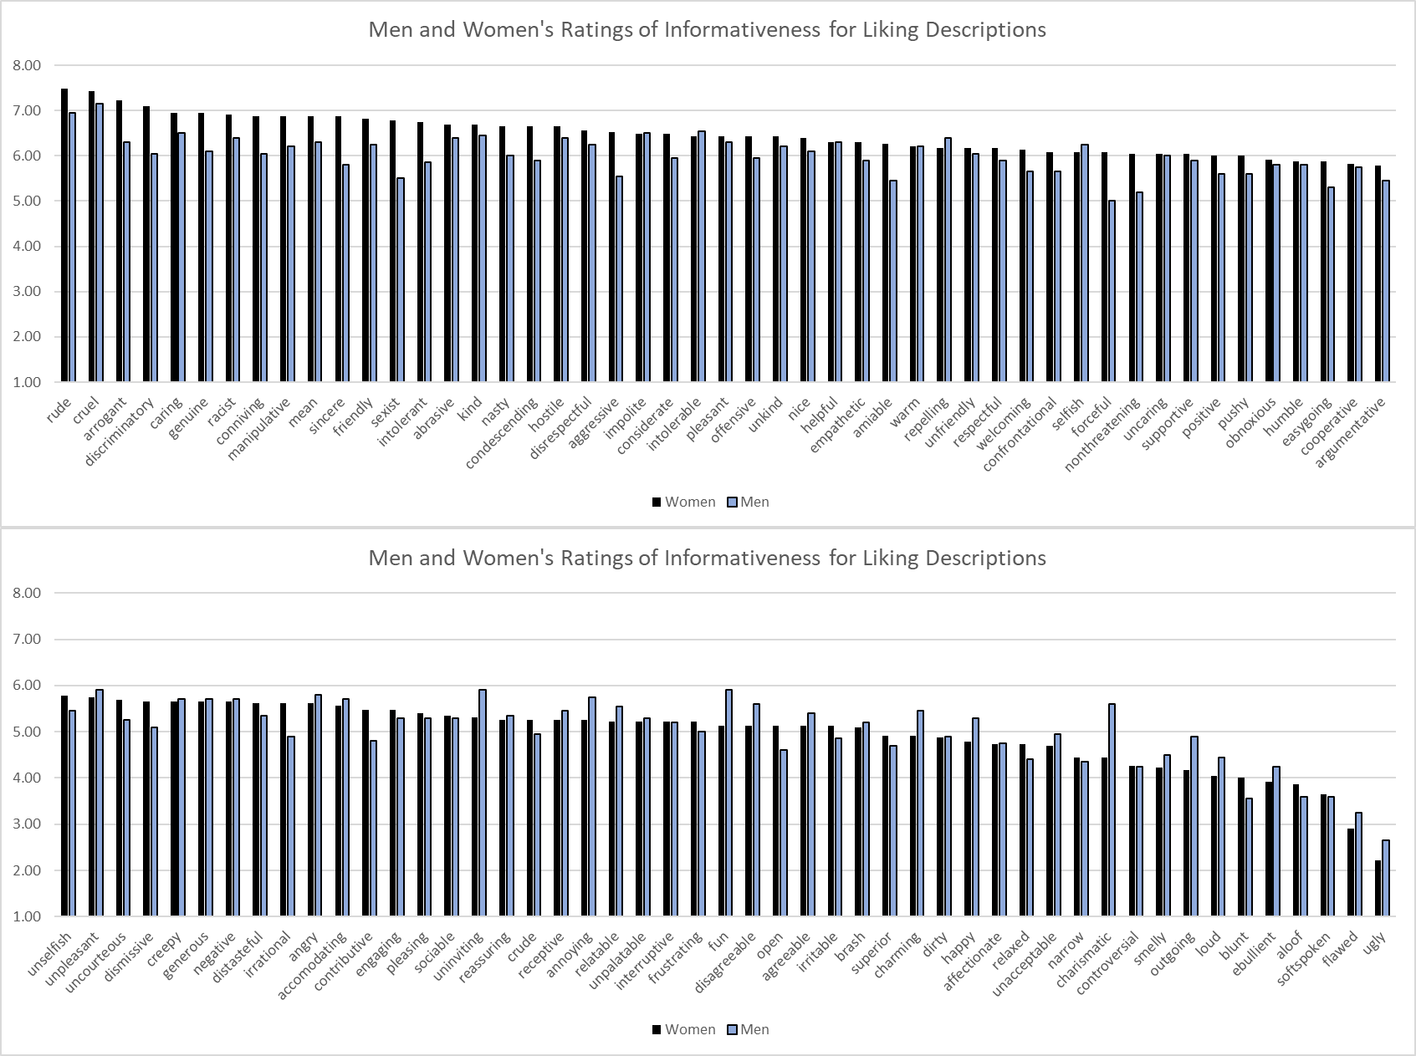

Moderation by Age in Study 2 Liking Description Set

To test whether older and younger people provided different informativeness ratings of the descriptions of liking, we examined a mixed GLM in which the 98 descriptions were a within subjects factor and age was a continuous predictor. Their interaction was also included. In this model there was no main effect of age, F(1, 41) = .69, p = .41, suggesting that older and younger people did not differ in their overall reported levels of informativeness. There was a main effect of descriptions, F(97, 3977) = 14.94, p <.001, consistent with the idea that some descriptions were more informative than others. Most importantly, there was no significant age x description interaction, F(97, 3977) = 1.11, p = .22, suggesting that there were not differences in how older and younger people rated the informativeness of some of the descriptions. Because there may be concerns that we did not observe an interaction due to lack of power, we have graphed the mean informativeness ratings for each description among older (+1 SD from the mean) and younger (-1SD from the mean) below so readers can note any descriptive differences. Of note, young people seem to perceive discriminatory attitudes (racism, sexism) to be more informative about how likeable someone is.
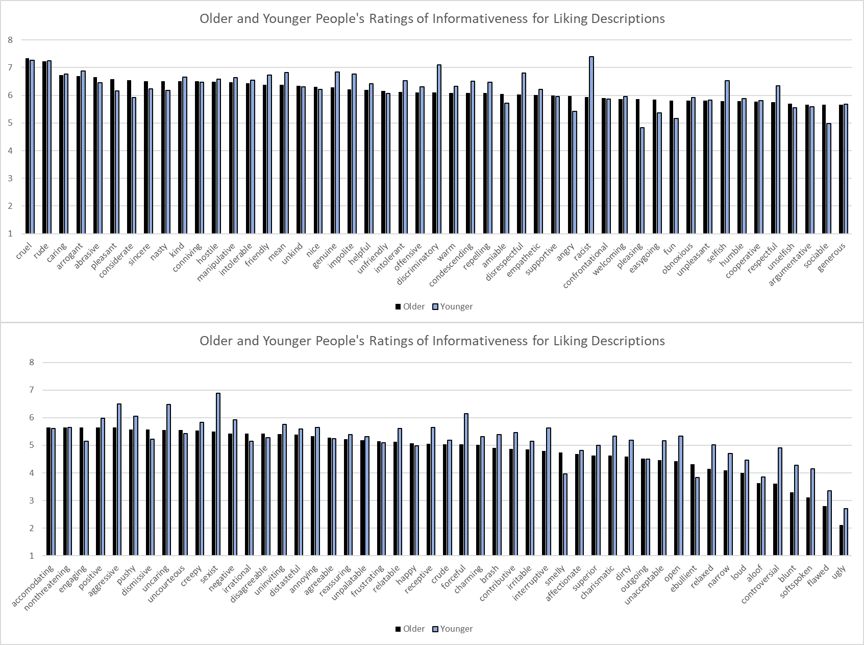

Moderation by Gender in Study 2 Trustworthiness Description Set

To test whether men and women provided different informativeness ratings of the descriptions of trustworthiness, we examined a mixed GLM in which the 34 descriptions were a within subjects factor and gender was a between subjects factor. In this model there was not a significant main effect of gender, F(1, 45) = .01, p = .94, suggesting that men and women overall reported relatively similar levels of informativeness. There was a main effect of descriptions, F(33, 1485) = 28.54, p <.001, consistent with the idea that some descriptions were more informative than others. Most importantly, there was not a significant gender x description interaction, F(33, 1485) = 1.20, p = .20, suggesting that men and women rated the informativeness of each description relatively equally. Readers may be concerned that there would be a significant interaction if we had a larger sample size so we have graphed men and women’s informativeness ratings for each description below so readers can note any descriptive differences.
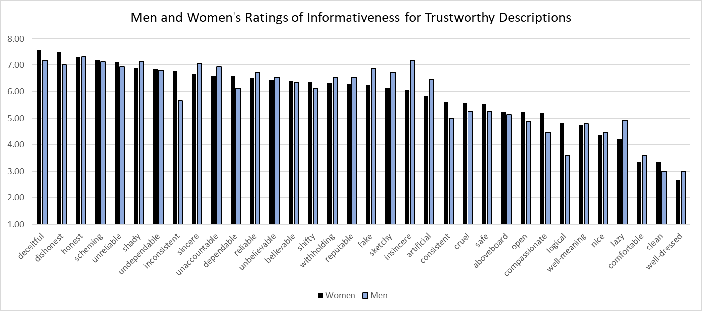

Moderation by Age in Study 2 Trustworthiness Description Set

To test whether older and younger people provided different informativeness ratings of the descriptions of trustworthiness, we examined a mixed GLM in which the 34 descriptions were a within subjects factor and age was a continuous predictor. Their interaction was also included. In this model there was a marginally significant main effect of age, F(1, 45) = 3.48, p = .07, suggesting that older and younger people might have differed in their overall reported levels of informativeness. There was a main effect of descriptions, F(33, 1485) = 32.81, p <.001, consistent with the idea that some descriptions were more informative than others. Most importantly, there was a significant age x description interaction, F(33, 1485) = 1.94, p = .001, suggesting that there were some differences in how older and younger people rated the informativeness of some of the descriptions. We have graphed the mean informativeness ratings for each description among older (+1 SD from the mean) and younger (-1SD from the mean) below so readers can note any differences. Some of these differences seem like they could reflect cohort differences in vernacular.
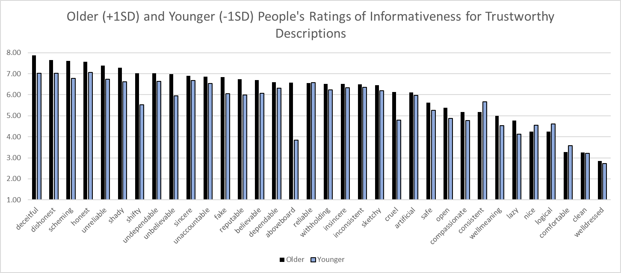

Moderation by Gender in Study 2 Expertise Description Set

To test whether men and women provided different informativeness ratings of the descriptions of expertise, we examined a mixed GLM in which the 49 descriptions were a within subjects factor and gender was a between subjects factor. In this model there was not a significant main effect of gender, F(1, 39) = .96, p = .33, suggesting that men and women overall reported relatively similar levels of informativeness. There was a main effect of descriptions, F(48, 1872) = 14.01, p <.001, consistent with the idea that some descriptions were more informative than others. Most importantly, there was a marginally significant gender x description interaction, F(48, 1872) = 1.33, p = .07, suggesting that men and women may have rated the informativeness of each description a bit differently. Therefore, we have graphed men and women’s informativeness ratings for each description below so readers can note any descriptive differences.
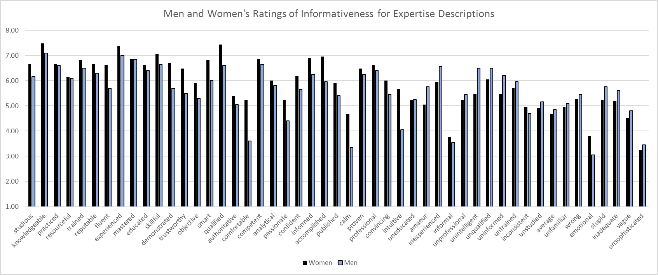

Moderation by Age in Study 2 Expertise Description Set

To test whether older and younger people provided different informativeness ratings of the descriptions of expertise, we examined a mixed GLM in which the 49 descriptions were a within subjects factor and age was a continuous predictor. Their interaction was also included. In this model there was not a significant main effect of age, F(1, 39) = .01, p = .92, suggesting that older and younger people did not differ in their overall reported levels of informativeness. There was a main effect of descriptions, F(48, 1872) = 13.97, p <.001, consistent with the idea that some descriptions were more informative than others. Most importantly, there was not a significant age x description interaction, F(48, 1872) = 1.21, p = .15, suggesting that there were not differences in how older and younger people rated the informativeness of some of the descriptions. We have graphed the mean informativeness ratings for each description among older (+1 SD from the mean) and younger (-1SD from the mean) below so readers can note any descriptive differences.
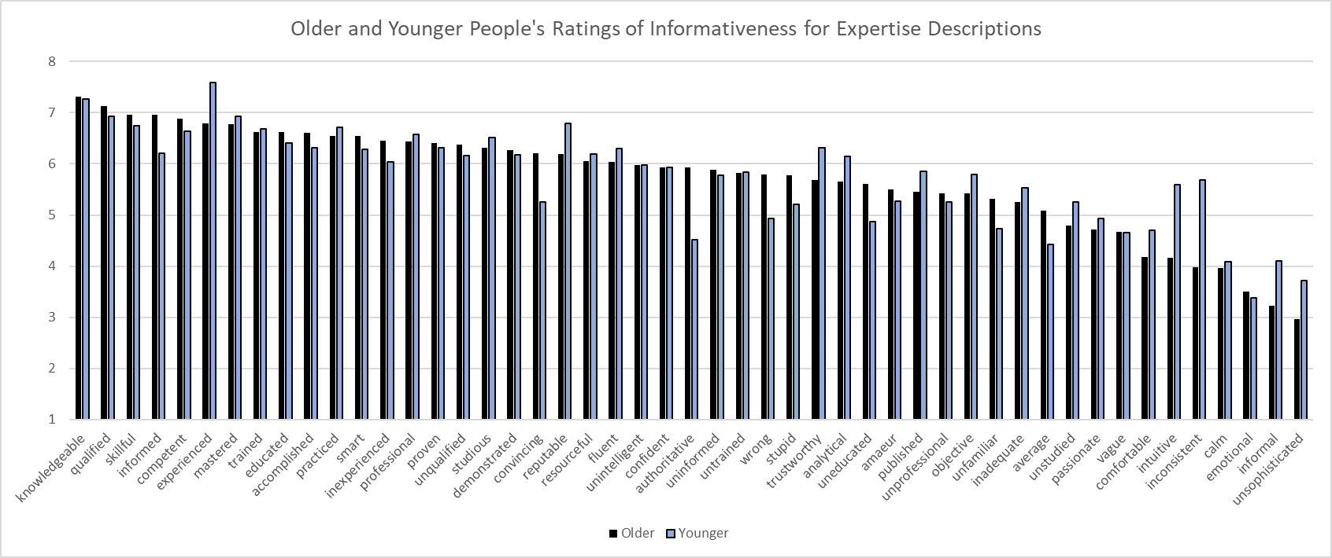

Moderation by Gender in Study 2 Powerfulness Description Set

To test whether men and women provided different informativeness ratings of the descriptions of powerfulness, we examined a mixed GLM in which the 70 descriptions were a within subjects factor and gender was a between subjects factor. In this model there was not a significant main effect of gender, F(1, 38) = 2.93, p = .10, suggesting that men and women overall reported relatively similar levels of informativeness. There was a main effect of descriptions, F(69, 2622) = 14.83, p <.001, consistent with the idea that some descriptions were more informative than others. Most importantly, there was a marginally significant gender x description interaction, F(69, 2622) = 1.24, p = .09, suggesting that men and women may have rated the informativeness of each description a bit differently. Therefore, we have graphed men and women’s informativeness ratings for each description below so readers can note any descriptive differences.
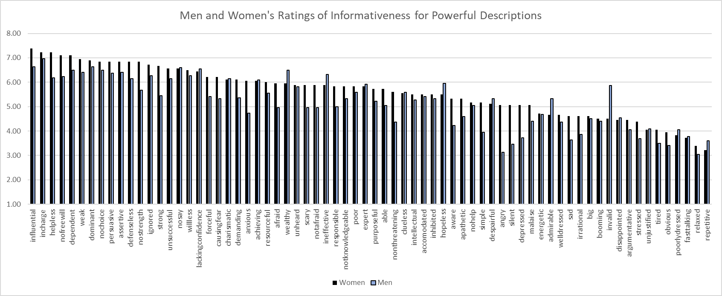

Moderation by Age in Study 2 Powerful Description Set

To test whether older and younger people provided different informativeness ratings of the descriptions of powerfulness, we examined a mixed GLM in which the 70 descriptions were a within subjects factor and age was a continuous predictor. Their interaction was also included. In this model there was not a significant main effect of age, F(1, 38) = 1.04, p = .31, suggesting that older and younger people might have differed in their overall reported levels of informativeness. There was a main effect of descriptions, F(69, 2622) = 15.03, p <.001, consistent with the idea that some descriptions were more informative than others. Most importantly, there was not a significant age x description interaction, F(69, 2622) = 1.23, p = .10, suggesting that there were not differences in how older and younger people rated the informativeness of some of the descriptions. We have graphed the mean informativeness ratings for each description among older (+1 SD from the mean) and younger (-1SD from the mean) below so readers can note any descriptive differences.
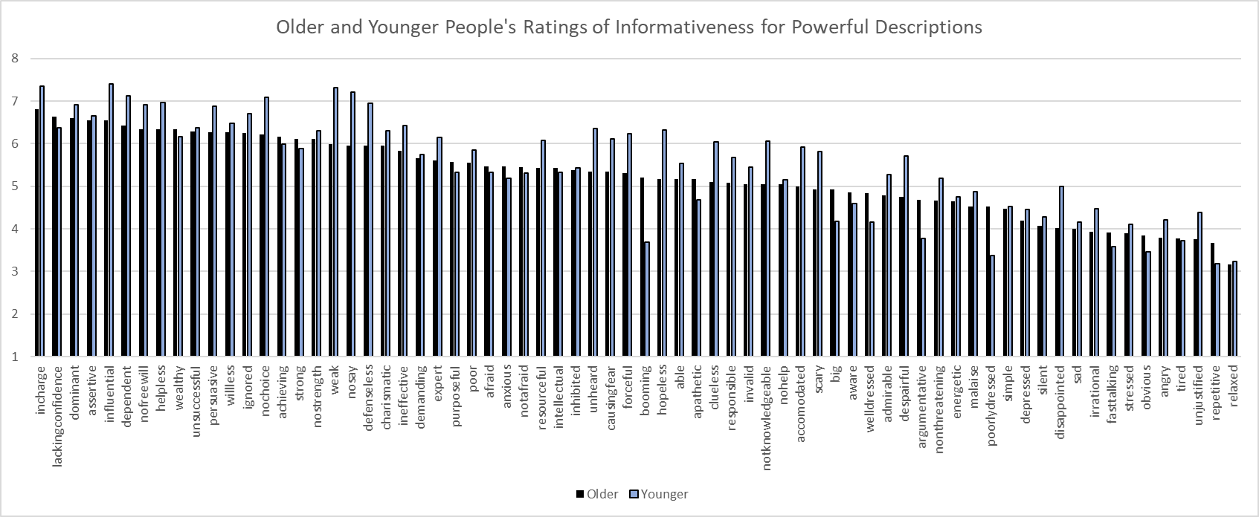

Moderation by Gender in Study 3

To examine moderation by gender in Study 3, for each set descriptions, we examined a mixed GLM with valence and trait within subjects factors and a gender between-subjects factor, along with their two and three-way interactions. Of most interest would be if we observed a three-way interaction, indicating that gender moderated the predicted valence x trait interaction. For the powerful, trustworthiness, and expertise description sets, there was no hint of three-way interaction, F(3, 51) = .94, p = .43; F(3, 57) = .97, p = .41; F(3, 57) = .47, p = .70, respectively. This suggested that gender did not moderate the predicted two-way interaction between valence and trait in these description sets. Because these p-values are so large, we think it is unlikely that these null results are the result of a lack of power.
However, for the liking set, there was a trending three-way interaction F(3, 57) = 1.65, p = .18. Because this p-value is relatively low and this interaction may not have reached significance because of a lack of power, we have graphed the results and examined simple interactions.
As demonstrated in the figure below, men and women each demonstrated similar patterns of results, but women tended to show larger effects of the valence factor across characteristics. However, men and women each demonstrated a significant trait x valence interaction, as predicted. Men: F(3, 33) = 40.79, p < .001; Women: F(3, 68) = 94.67, p < .001. Further, examination of the pattern below suggests that men and women demonstrated very similar patterns of results.
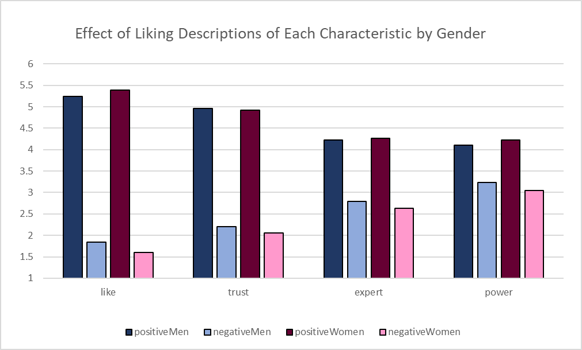

Moderation by Age in Study 3

To examine moderation by age in Study 3, for each of the characteristic sets, we examined a mixed GLM in which the valence and trait were within subjects factors and age was a continuous predictor. We also examined their two- and three-way interactions. Of most interest would be a three-way interaction indicating that age moderated the valence x trait interaction.
Liking Set
In the liking set, this unpredicted three-way interaction was not statistically significant, F(3, 102) = 1.53, p = .21, but the p-value was small enough that readers may be concerned that there would be an effect with more power. Despite this possible three-way interaction, older and younger people demonstrated very similar results, each demonstrating the predicted trait x valence interaction: Older (+1 SD), F(3, 102) = 60.25, p <.001; Younger (-1SD), F(3, 102) = 81.71, p <.001.

This three-way interaction reflected that older people showed a significantly larger effect of the valence factor on power ratings than did younger people, F(1, 104) = 7.01, p = .009. This meant that age served as a moderator when comparing the difference the valence factor created in the liking versus power characteristics and the trustworthiness versus power characteristics. (See table below, which contains the valence x trait x age simple interactions for each pair of characteristics). However, as is clear from the figure below, older and younger people demonstrate extremely similar patterns of results. In fact, older, F(1,104)= 152.25, p <.001, and younger, F(1,104)= 224.32, p <.001, people both demonstrated a wildly significant interaction when comparing the differences that the valence factor created on liking versus power. Similarly, when comparing the differences on the trustworthiness versus powerful characteristics, both older, F(1,104)= 87.44, p <.001, and younger, F(1,104)= 96.35, p <.001, people demonstrated wildly significant interactions.

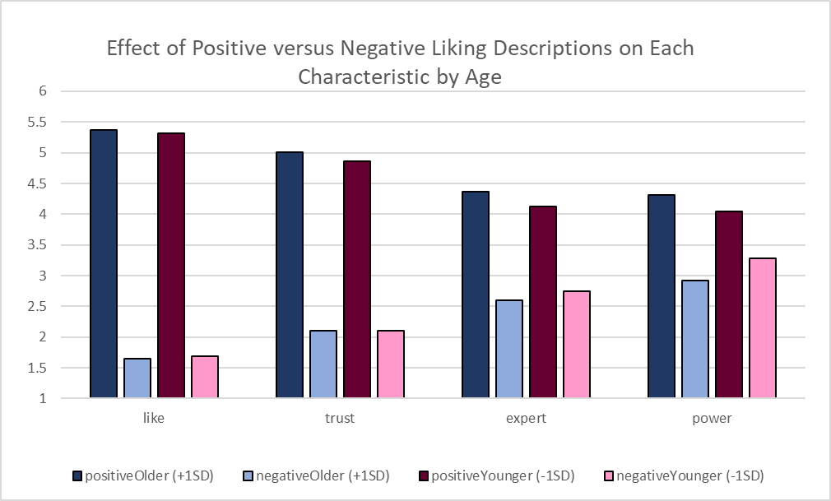
Trait x Valence x Age simple interaction for each combination of characteristics.
 | Trust | Expert | Power
Like | F(1, 104) = .19, p = .69 | F(1, 59) = 1.78, p = .19 | F(1, 59) = 4.26, p = .04
Trust | --- | F(1, 59) = 1.63, p = .21 | F(1, 59) = 3.87, p = .05
Expert |  | --- | F(1, 59) = 2.70, p = .10
Trustworthiness Set
In the trustworthiness set, the trait x valence x age three-way interaction was marginally significant, F(3, 57) = 2.49, p = .07. Despite this three-way interaction, older and younger people demonstrated very similar results, each demonstrating the predicted trait x valence interaction: Older (+1 SD), F(3, 57) = 13.14, p <.001; Younger (-1SD), F(3, 57) = 32.89, p <.001.

This three-way interaction reflected that older people showed a significantly larger effect of the valence factor on power ratings, F(1, 59) = 7.93, p = .007, and expertise ratings, F(1, 59) = 4.45, p = .04, than did younger people. This meant that age served as a moderator when comparing the difference the valence factor created in the liking versus expertise, liking versus power, and the trustworthiness versus power characteristics. (See table below, which contains the valence x trait x age simple interactions for each pair of characteristics). However, as is clear from the figure below, older and younger people demonstrated extremely similar patterns of results. When comparing the valence difference on liking versus expertise, older people, F(1,59)= 18.73, p <.001, and younger people, F(1,59)= 59.40, p <.001, demonstrated the same interaction. Similarly, when comparing the valence difference on liking versus power, older people, F(1,59)= 22.75, p <.001, and younger people, F(1,59)= 84.18, p <.001, demonstrated the same interaction. Finally, when comparing the difference on trustworthiness and power, older, F(1,59)= 37.71, p <.001, and younger, F(1,59)= 101.31, p <.001, people demonstrated the same interaction.

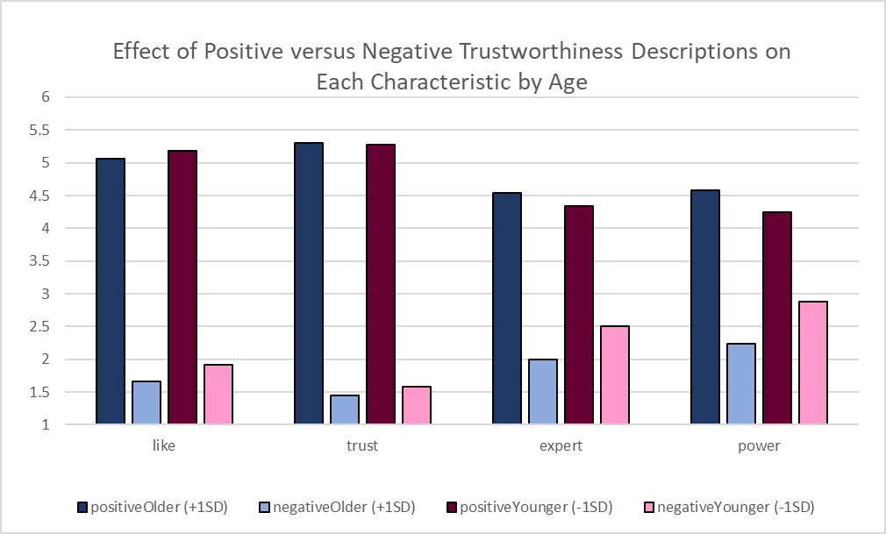
Trait x Valence x Age simple interaction for each combination of characteristics.
 | Trust | Expert | Power
Like | F(1, 59) = .03, p = .86 | F(1, 59) = 4.43, p = .04 | F(1, 59) = 7.71, p = .007
Trust | --- | F(1, 59) = 2.97, p = .09 | F(1, 59) = 5.75, p = .02
Expert |  | --- | F(1, 59) = 1.89, p = .18
Power |  |  | ---

Expertise Set
In the expertise set, the trait x valence x age three-way interaction was not statistically significant, F(3, 57) = 1.91, p = .14. Older and younger people demonstrated very similar results, each demonstrating the predicted trait x valence interaction: Older (+1 SD), F(3, 57) = 23.63, p <.001; Younger (-1SD), F(3, 57) = 23.45, p <.001.

We examined whether age moderated each of the simple valence x trait interactions comparing each of the individual characteristics. Age marginally significantly moderated the comparison between liking and power and significantly moderated the comparison between trustworthiness and power. (See table below, which contains the valence x trait x age simple interactions for each pair of characteristics). When comparing the valence difference on liking versus power, older people, F(1,59)= 36.19, p <.001, and younger people, F(1,59)= 12.52, p <.001, demonstrated the same interaction. Finally, when comparing the difference on trustworthiness and power, older people demonstrated an interaction, F(1,59)= 12.90, p <.001, whereas younger people did not, F(1,59)= .09, p = .76. This reflects that older people view expertise and power as more closely tied together than expertise and trustworthiness, but younger people view expertise as equally tied to power and trustworthiness.

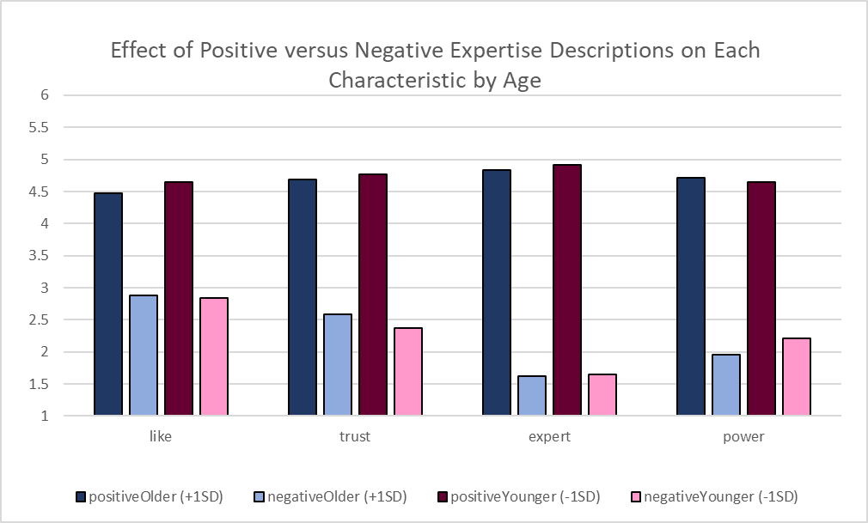
Trait x Valence x Age simple interaction for each combination of characteristics.
 | Trust | Expert | Power
Like | F(1, 59) = .14, p = .71 | F(1, 59) = .37, p = .55 | F(1, 59) = 3.65, p = .06
Trust | --- | F(1, 59) = .85, p = .36 | F(1, 59) = 5.55, p = .02
Expert |  | --- | F(1, 59) = 2.38, p = .13
Power |  |  | ---

Power Set
In the power set, the trait x valence x age three-way interaction was not statistically significant, F(3, 51) = 2.01, p = .13. Older and younger people demonstrated very similar results, each demonstrating the predicted trait x valence interaction: Older (+1 SD), F(3, 51) = 29.80, p <.001; Younger (-1SD), F(3, 51) = 12.40, p <.001.

We examined whether age moderated each of the simple valence x trait interactions comparing each of the individual characteristics. Age significantly each of the comparisons of power with the other characteristics. (See table below, which contains the valence x trait x age simple interactions for each pair of characteristics). Despite these interactions, older and younger people demonstrated remarkably similar results. When comparing the valence difference on liking versus power, older people, F(1,53)= 86.97, p <.001, and younger people, F(1,53)= 30.31, p <.001, demonstrated the same interaction. When comparing the difference on trustworthiness and power, older people, F(1,53)= 90.74, p <.001, and younger people, F(1,53)= 38.06, p <.001, both demonstrated an interaction. Finally, when comparing power and expertise, both older, F(1,53)= 69.23, p <.001, and younger, F(1,53)= 21.50, p <.001, people significantly demonstrated the same interaction.

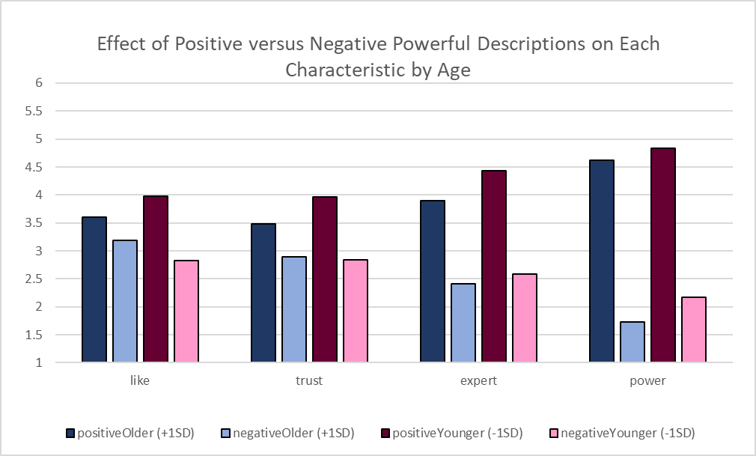
Trait x Valence x Age simple interaction for each combination of characteristics.
 | Trust | Expert | Power
Like | F(1, 53) = 1.90, p = .17 | F(1, 53) = 2.13, p = .15 | F(1, 53) = 5.47, p = .02
Trust | --- | F(1, 53) = .51, p = .48 | F(1, 53) = 4.08, p = .05
Expert |  | --- | F(1, 53) = 5.17, p = .03
Power |  |  | ---

Attributes generated for each characteristic graphed along each possible pair of characteristics

