Online Supplementary Materials
Contents
Objective ambivalence $×$ affective-cognitive message factor $×$ affective-cognitive topic orientation interaction predicting subjective ambivalence in Study 2 2
Study 4 Analyses Without Participants Who Failed Attention Check 4
Meta-Analysis of All Studies in This Research 6
Empirical Evidence for Matching Effects in Counter-Attitudinal Individuals Only 8
Exploratory Moderated Mediation Analysis 13

Objective ambivalence $×$ affective-cognitive message factor $×$ affective-cognitive topic orientation interaction predicting subjective ambivalence in Study 2
To ensure that the objective ambivalence $×$ matched-mismatched message factor patterns were as hypothesized in both the manipulated affective and cognitive topic orientations, we also examined the objective ambivalence $×$ affective-cognitive message factor $×$ affective-cognitive topic orientation interaction. Importantly, the three-way interaction was significant, $B$ = 0.694, 95%CI: [0.024, 1.365], t(149) = 2.046, p = .043, r_{partial} = .165.
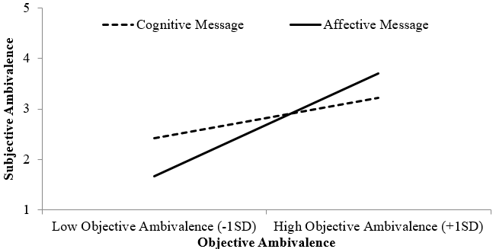
Figure S1. Objective ambivalence $×$ affective-cognitive message factor interaction for the affective topic manipulation.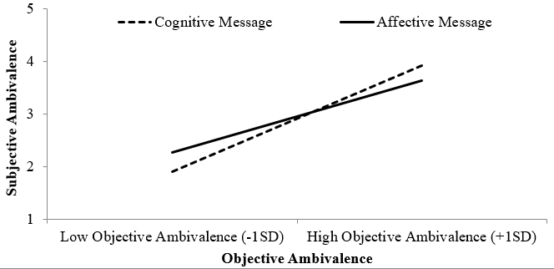
Figure S2. Objective ambivalence $×$ affective-cognitive message factor interaction for the cognitive topic manipulation.
Among those who received the affective topic manipulation, there was a significant objective ambivalence $×$ affective-cognitive message factor interaction, $B$ = 0.461, 95%CI: [0.002, 0.919], t(149) = 1.985, p = .049, r_{partial} = .160. For those who received a cognitive message, higher objective ambivalence did not predict subjective ambivalence, $B$ = 0.285, 95%CI: [-0.054, 0.625], t(149) = 1.663, p = .098, r_{partial} = .135. However, for those who received an affective message, objective ambivalence did positively predict subjective ambivalence, $B$ = 0.748, 95%CI: [0.437, 1.058], t(149) = 4.762, p < .001, r_{partial} = .363 (Figure S1). On the other hand, for those who received the cognitive topic manipulation, they demonstrated a directional interaction effect in the opposite direction, $B$ = -0.236, 95%CI: [-0.726, 0.255], t(149) = -0.949, p = .344, r_{partial} = -.078. For those who received a cognitive message, higher objective ambivalence meant higher subjective ambivalence, $B$ = 0.738, 95%CI: [0.417, 1.060], t(149) = 4.539, p < .001, r_{partial} = .349. For those who received an affective message, objective ambivalence showed a weaker association to subjective ambivalence, B = 0.502, 95%CI: [0.131, 0.873], t(149) = 2.676, p = .008, r_{partial} = .214 (Figure S2).

Study 4 Analyses without participants who failed attention check
We reran the hypothesized three-way interaction with data excluding the eight participants who failed the attention check ($M_{age}$ = 34.79, SD = 11.81, 54.30% female). We added attention check items to this study as it was conducted online with the intention to ensure the data’s quality by excluding those who failed at least one of the checks (Niessen et al., 2016). Participants were randomly assigned to either an affective (N = 133) or cognitive message (N = 147). Most importantly, we replicated the significant three-way interaction$, B$ = 0.243, 95%CI: [0.062, 0.423], t(264) = 2.644, p = .009, r_{partial} = .161. We decomposed this again by comparing individuals with positive versus negative attitudes. 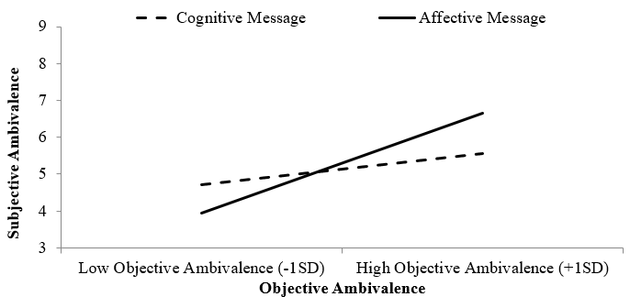
Figure S3. A counter-attitudinal message demonstrated a stronger objective-subjective ambivalence relationship when receiving a matched affective message versus a mismatched cognitive message.
Among those with positive attitudes toward sugary drinks (i.e., message was counter-attitudinal), there was a significant two-way interaction between objective ambivalence and affective-cognitive message factor, $B$ = 0.400, 95%CI: [0.098, 0.701], t(264) = 2.611, p = .010, r_{partial} = .112. Consistent with earlier interaction patterns, for those in the affective message condition (the matched condition, in this study), objective ambivalence positively corresponded to subjective ambivalence, $B$ = 0.583, 95%CI: [0.354, 0.811], t(264) = 5.022, p < .001, r_{partial} = .295. As expected, for those in the cognitive message condition, the correspondence was weaker and marginal, $B$ = 0.180, 95%CI: [-0.015, 0.379], t(264) = 1.821, p = .070, r_{partial} = .111.
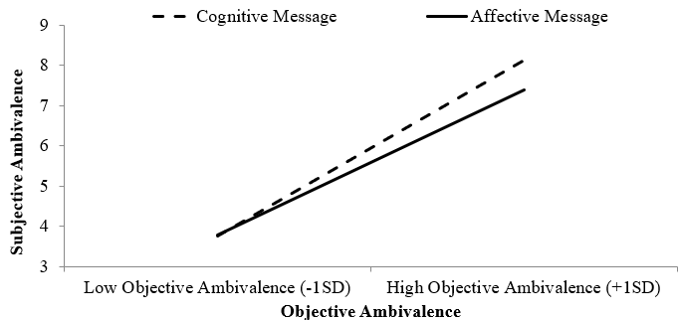
Figure S4. Participants who received a pro-attitudinal message did not show significant differences in objective-subjective ambivalence relationship regardless of the message received.
A different pattern was observed for those with negative initial attitudes (i.e., message was pro-attitudinal): there was no significant interaction between objective ambivalence and affective-cognitive message factor, $B$ = -0.166, 95%CI: [-0.422, 0.090], t(264) = -1.275, p = .203, r_{partial} = -.078. When the message was pro-attitudinal, objective ambivalence was associated with subjective ambivalence, regardless of whether they received an affective message, $B$ = 0.778, 95%CI: [0.593, 0.962], t(264) = 8.306, p < .001, r_{partial} = .455, or a cognitive message condition, B = 0.944, 95%CI: [0.766, 1.122], t(264) = 10.439, p < .001, r_{partial} = .447.

Meta-Analysis of All Studies in This Research
We conducted a meta-analysis to further examine the robustness of the matching effect between message and topic at increasing objective-subjective ambivalence correspondence. The effect sizes were computed such that a larger positive correlation indicated a stronger objective-subjective ambivalence correspondence (Cheung, 2015; Goh et al., 2016; Rosenthal & Rosnow, 2008). The analyses were conducted in the R (version 4.0.3) statistical platform using the metaSEM (Cheung, 2020) and metafor package (Viechtbauer, 2020). Consistent with earlier results, the meta-analysis also supported a significant objective ambivalence $×$ matched-mismatched message interaction effect, producing a r = 0.145, 95%CI: [0.0655, 0.225], Z = 3.573, p < .001 (Figure S3). The Rosenberg failsafe number was revealed to be 22, which meant that an additional 22 experiments with an average observed sample size of 209.40 (i.e., total N = 4,606) would be needed to reduce the observed meta-analytic effect to a negligible magnitude (Fabrigar & Wegener, 2016).
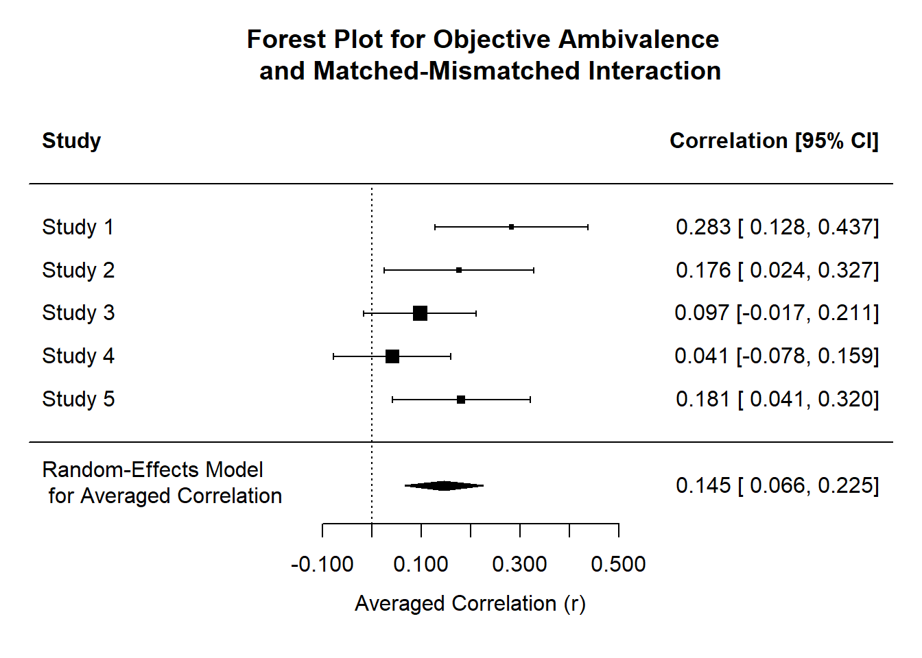
Figure S3. Forest plot of combined matching effects for all studies in current research.
More importantly, consistent with our postulation, receiving a matched message did result in stronger objective-subjective ambivalence correspondence (r = .387, 95%CI: [.268, .506], Z = 6.394, p < .001) compared to receiving a mismatched message (r = .239, 95%CI: [.054, .424], Z = 2.531, p = .011). Hence, the meta-analysis provides additional confidence for our observed findings.

Empirical Evidence for Matching Effects in Counter-Attitudinal Individuals Only
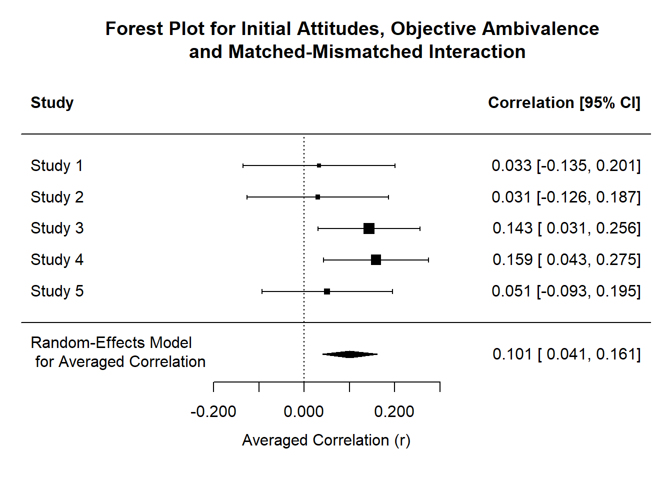
Figure S4. Forest plot for combined three-way effects of all studies in current research.
We also conducted a meta-analysis to further examine the influence of attitudinal position on the matching two-way effects. We had expected the effects to be driven by those who received a counter-attitudinal message given that the experience of ambivalence tend to increase as a function of increasing conflicts (Priester & Petty, 1996). Consistent with earlier results, the meta-analysis also supported the significant initial attitudes $×$objective ambivalence $×$ matched-mismatched message interaction effect, producing a r = 0.101, 95%CI: [0.041, 0. 161], Z = 3.292, p = .001 (Figure S4). The Rosenberg failsafe number was revealed to be 10, which meant that an additional 10 experiments with an average observed sample size of 209.40 (i.e., total N = 2,094) would be needed to reduce the observed meta-analytic effect to a negligible magnitude (Fabrigar & Wegener, 2016).
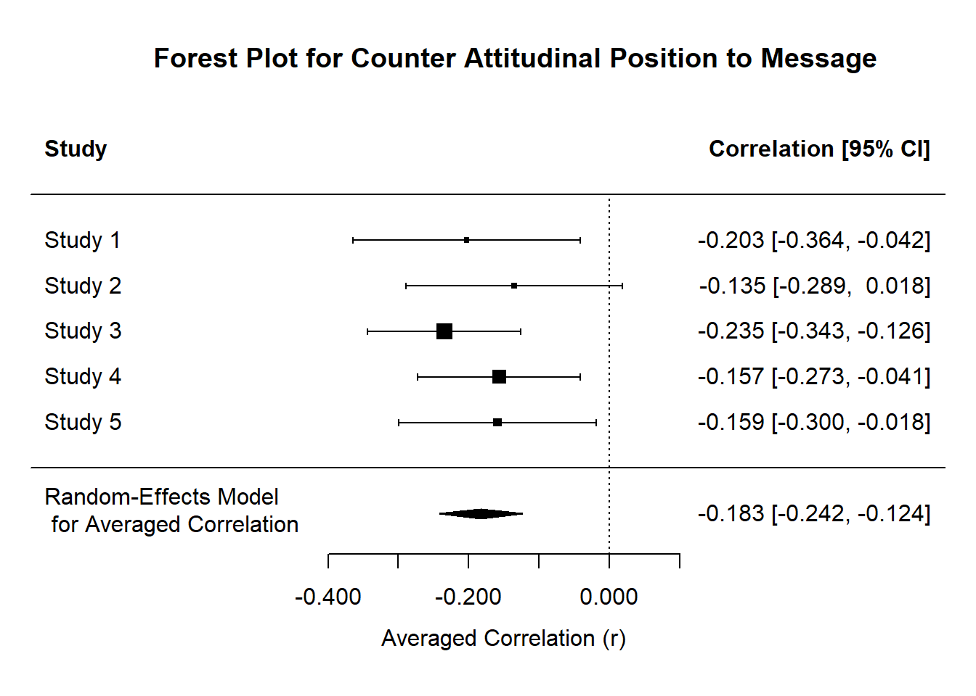
Figure S5a. Forest plot for combined two-way interaction effect in participants receiving counter-attitudinal message for all studies in current research.
More importantly, consistent with our hypotheses, only those with counter-attitudinal position showed the matching effects, r = -0.183, 95%CI: [-0.242, -0.124], Z = -6.107, p < .001.
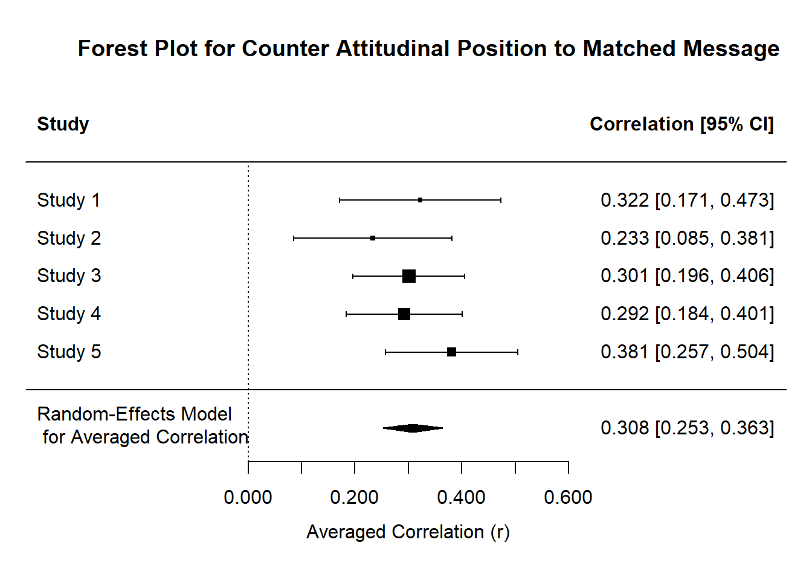
Figure S5b. Forest plot for objective-subjective correspondence in participants receiving matched counter-attitudinal message for all studies in current research.
That is, for those with a matched message and topic orientation, having more objective ambivalence meant more subjective ambivalence, r = 0.308, 95%CI: [0.253, 0.363], Z = 10.987, p < .001.
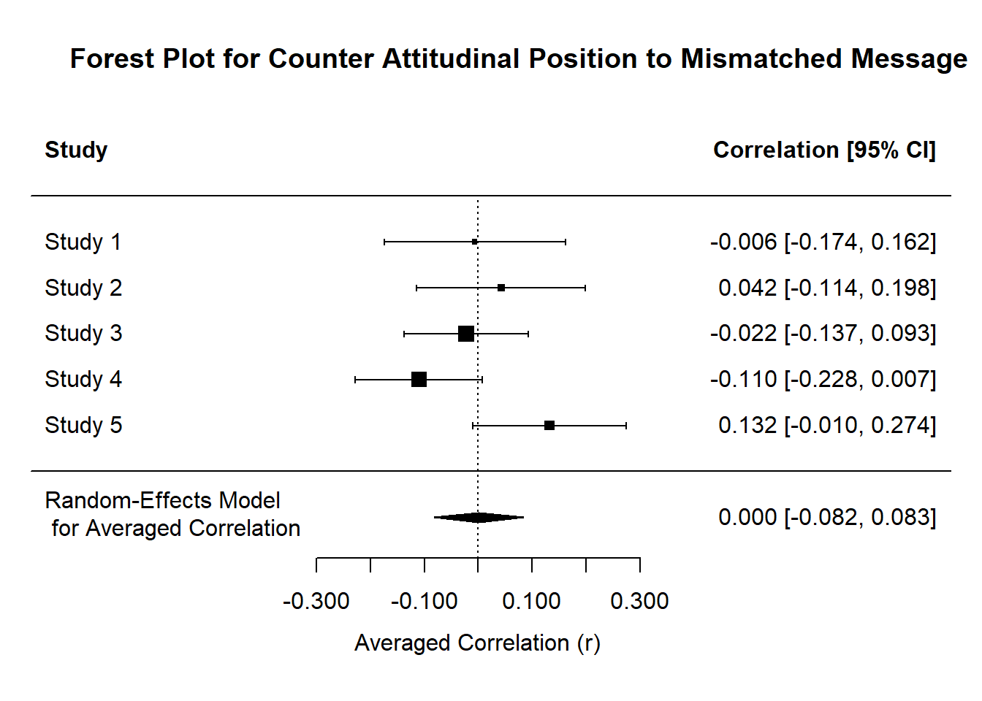
Figure S5b. Forest plot for lack of objective-subjective correspondence in participants receiving matched counter-attitudinal message for all studies in current research.
However, for those with a mismatched message and topic orientation, objective ambivalence and subjective ambivalence did not correspond significantly, r < 0.001, 95%CI: [-0.082, 0.083], Z = 0.011, p = .991.
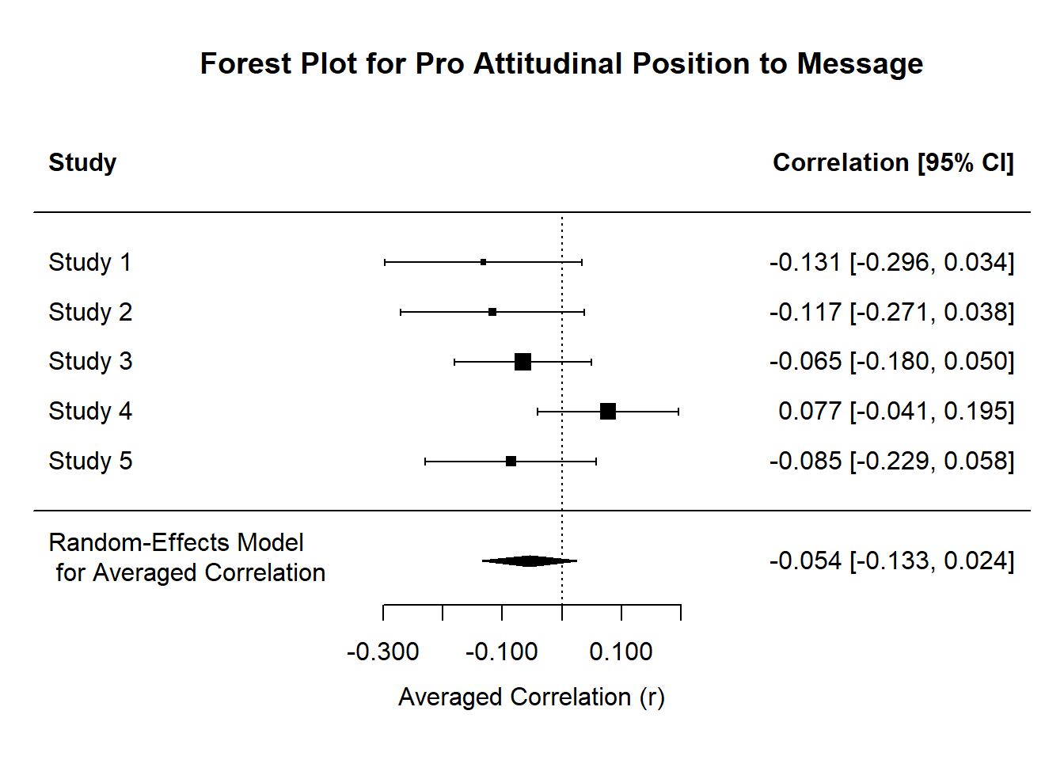
Figure S5d. Forest plot for lack of combined two-way interaction effect in participants receiving pro-attitudinal message for all studies in current research.
Finally, as expected, we did not observe any interaction effects for those with pro-attitudinal position to the message they encountered, r = -0.054, 95% CI: [-0.133 0.024], Z = -1.356, p = .175.

Exploratory Moderated Mediation Analysis
Objective-Subjective Ambivalence Difference

Pre-Message Attitude
Moderation for Mediator: $B$ = 0.431, 95% CI: [-0.038, 0.899]
Moderation for Outcome: $B$ = -0.456, 95% CI: [-0.762, -0.150]
Moderated Mediation Index: $B$ = 0.009, 95% CI: [-0.057, 0.077].

Fluency

Match

Figure S6a. Moderated mediation model for matched-mismatched message moderated by pre-message attitudes to influence perceived fluency and objective-subjective ambivalence differences.
Adapting from Graf et al. (2018), we measured the perceived fluency of the conflicting negative reactions since participants generally felt more positive about sweetened drinks (M = 3.891, SD = 1.075) with one item, “The process of recalling my negative evaluations of sweetened drinks was __________. (1-Difficult, 9-Easy)”. To capture the discrepancy between the two ambivalence constructs, we took the absolute of the objective ambivalence and minus the subjective ambivalence from it (discrepancy = |objective ambivalence| - subjective ambivalence), where larger value meant greater difference. We then ran a moderated mediation using model 8 of the PROCESS module with 5000 bootstraps (Hayes, 2017). Overall, it did not reveal a significant moderated mediation, $B$ = 0.009, 95% CI: [-0.059, 0.078]. However, we continued to probe for the patterns for people with positive (counter-attitudinal to message) or negative attitudes (pro-attitudinal to message) toward sweetened drinks.

Negative Pre-Message Attitudes
$B$ = -0.446, 95%CI: [-1.160, 0.268]
$B$ = 0.630, 95% CI: [0.166, 1.095]
Fluency
Indirect Effect: $B$ = -0.009, 95% CI: [-0.057, 0.077].

Match
Objective-Subjective Ambivalence Difference

Figure S6b. Moderated mediation model for matched-mismatched message in those with negative pre-message attitudes.
For those with negative (pro-atttudinal to message) attitudes, a matched message resulted in less fluency than a mismatched message, B = -0.446, 95%CI: [-1.160, 0.268]. A matched message also resulted in greater objective-subjective ambivalence discrepancy, $B$ = 0.630, 95% CI: [0.166, 1.095]. However, there was no significant mediation via fluency, $B$ = -0.009, 95% CI: [-0.073, 0.075].

Positive Pre-Message Attitudes
$B$ = 0.479, 95%CI: [-0.225, 1.184]
$B$ = -0.351, 95% CI: [-0.809, 0.108]

Fluency
Indirect Effect: $B$ = 0.010, 95% CI: [-0.060, 0.115].

Match
Objective-Subjective Ambivalence Difference

Figure S6c. Moderated mediation model for matched-mismatched message in those with positive pre-message attitudes.
For those with positive (counter-atttudinal to message) attitudes, a matched message resulted in more fluency than a mismatched message, $B$ = 0.479, 95%CI: [-0.225, 1.184]. A matched message also showed a trend of lesser objective-subjective ambivalence discrepancy $B$ = -0.351, 95%CI: [-0.809, 0.108]. However, there was again no significant mediation via fluency, $B$ = 0.010, 95%CI: [-0.060, 0.115].

References
Cheung, M. W. -L. (2015). Meta-analysis: A structural equation modelling approach. Western Sussex, United Kingdom.
Cheung, M. W. -L. (2020). metaSEM: An R package for meta-analysis using structural equation modelling. Retrieved from https://cran.r-project.org/web/packages/metaSEM/index.html
Fabrigar, L. R., & Wegener, D. T. (2016). Conceptualizing and evaluating the replication of research results. Journal of Experimental Social Psychology, 66, 68-80. doi:10.1016/j.jesp.2015.07.009
Goh, J. X., Hall, J. A., & Rosenthal, R. (2016). Mini meta-analysis of your own studies: Some arguments on why and a primer on how. Social and Personality Compass, 10, 535-549. doi:10.1111/spc3.12267
Graf, L. K. M., Mayer, S., & Landwehr, J. R. (2018). Measuring processing fluency: One versus five items. Journal of Consumer Psychology, 28, 393-411. doi:10.1002/jcpy.1021
Hayes, A. F. (2017). Introduction to mediation, moderation, and conditional process analysis: A regression approach (2nd ed.). New York: The Guilford Press.
Niessen, A. S. M., Meijer, R. R., & Tendeiro, J. N. (2016). Detecting careless respondents in web-based questionnaires: Which method to use? Journal of Research in Personality, 63, 1-11. doi:10.1016/j.jrp.2016.04.010
Viechtbauer, W. (2020). metafor: Meta-analysis package for R. Retrieved from https://cran.r-project.org/web/packages/metafor/index.html

